

Tenant Engagement update
July-September 2025

1. Our North Tyneside Voice website

As of 30 September, 631 tenants are registered on the Our North Tyneside Voice website.
Being registered allows us to contact them whenever there is an opportunity for them to have their say via a consultation, or sign up to take part in an engagement activity.

Recent additions to the tenant hub of the website include a summary of our July drop-ins, our annual report 2024-25, promotion of the annual event, notes from our September tenant panels and a survey on communal block cleaning.

2. Tenant panels – September

The North Tyneside Living Panel heard an update from Morgan Sindall on repairs and some context behind missed repairs targets. They reviewed the current NTL handbook, ahead of it being refreshed and considered the proposal to introduce a formal Volunteer Agreement to reinforce roles and responsibilities of volunteers coming in to deliver activities. This will be taken forward with VODA.

The Estates and Communities Panel meeting began with a presentation on the ‘Knowing Our Customers’ work to improve the customer information we collect and how this is used to improve services. One of our tenants then led a discussion around social housing stigma, linked to a national campaign on this issue. There was acknowledgement that we are already doing a lot of the campaign’s recommendations, and we should continue to work on this. The panel reviewed the letters used by our Community Protection team and provided feedback ahead of them being updated. They also discussed anonymous reporting and agreed we should continue to accept anonymous reports, but with a disclaimer to say they would not be formally investigated.

The Repairs and Communities Panel also began with the ‘Knowing Our Customers’ item. They then reviewed the complaints report and recognised the effort that goes into the repairs service. Results of the recent kitchens consultation (see section 4) were shared and agreed. The panel then reviewed the performance scorecard and discussed changes to some targets which would remain challenging, but achievable, and the panel agreed to have these reflected on future scorecards. The final item was the quarterly Quality and Safety Report, which updates where we are in relation to Safety Standards.

The Landlord Panel reviewed the six-monthly equality and diversity report and the ‘Knowing Our Customers’ work, the quarterly Quality and Safety Report and the quarterly engagement report. They also discussed the draft Tenant Engagement Strategy (see section 7). There was then discussion of the performance scorecard and complaints data.

Leaseholder Panel: The annual service charge letter sent out over the summer included an invitation for leaseholders to contact us if they were interested in being part of a panel. Ten people responded, when added to the 12 who originally contacted us after an email sent earlier in the year, this would give us sufficient for a viable panel.

3. Annual event

Thank you to everyone who supported our event on Friday 26 September. We were delighted to welcome 35 tenants, who came along to share their views on the services we provide and hear about our plans for the future. There was excellent discussion around communication, supporting neighbourhoods and communities, as well as our approach to tenancy and financial support and condensation, mould and damp. We received really positive feedback from the tenants who attended. A write-up of the event will be sent to participants and shared via the Our North Tyneside Voice website shortly.

4. New kitchens consultation

A survey of current kitchen choices was carried out over the summer to get the views of tenants, ahead of a new supplier contract being sought. The current offer has a range of options for fixtures and fittings, and we know that some choices are more popular than others. Reducing the choices offered will save space, time and money. The survey was online, with paper copies available from our six community hubs and libraries. This was promoted via the Our North Tyneside Voice website, the council’s social media channels and via cards taken out by the repairs teams when calling at tenants’ homes. Additional consultation was carried out at our July tenant drop-ins.

A total of 204 responses were received. This was combined with data from recent new kitchen choices, meaning feedback was based on choices from over 400 tenants. The results were shared with our Repairs and Investment Panel in September and they agreed we should move to the reduced number of choices in future.

5. Tenant drop-ins

We were out and about again in July, following on from the success of our January drop-ins. Colleagues were on hand to help answer any questions or give advice relating to repairs, community protection and anti-social behaviour, neighbourhoods, and tenancy and financial support. We were delighted that 56 tenants came to talk to us at the White Swan Centre, Cedarwood Trust in Meadow Well and at a Saturday morning session at Battle Hill Library. More will be arranged for winter.
6. Tenants’ Annual Report 2024-25

After a review of the draft by tenants on our Landlord Panel, this has now been published and promoted as follows:
- On the Our North Tyneside Voice website, with a link sent to those registered
- On the council’s Facebook, linking to the web page
- Printed copies have been sent to all NTL schemes for their lounges
- Printed copies were available in our six community hubs and libraries
- Printed copies have been given to tenants attending panels and the annual event

7. Tenant Engagement Strategy 2025-29

This sets out our approach to offering accessible and inclusive opportunities for tenants to have their say and influence the services we provide. It includes our engagement structure, vision and objectives, how we will communicate with tenants about opportunities and how we evaluate and learn from the activities we offer. The draft was reviewed by our tenant panels in September and their feedback was incorporated into it. The strategy will be taken to Cabinet for formal approval on 20 October.

8. Reviews

- Tenancy Agreement: An updated draft was shared with tenants on our Estates and Communities Panel in June, inviting final comments in July. Several comments were received and that feedback has been incorporated into the final version of the Agreement.
- Vulnerabilities and Reasonable Adjustments / Aids and Adaptations Consultations: This was hosted on the Our North Tyneside Voice website during the summer and promoted to residents and community groups working with people who may be classed as ‘vulnerable’. Paper copies were available in the six community hubs and libraries. Only a few responses were received, but some changes to the drafts were made as a direct result of feedback.

9. Big Community Conversation

The council’s annual Big Community Conversation ran from June-August. This year’s survey asked what people like about North Tyneside and what they would like to see improved. We could filter the responses to only be those from council tenants, to use those results in our tenant programme. Feedback from the 244 tenants who responded was used during the planning for our annual event in September, focusing on their comments around neighbourhoods, communities and environment.
10. Social media

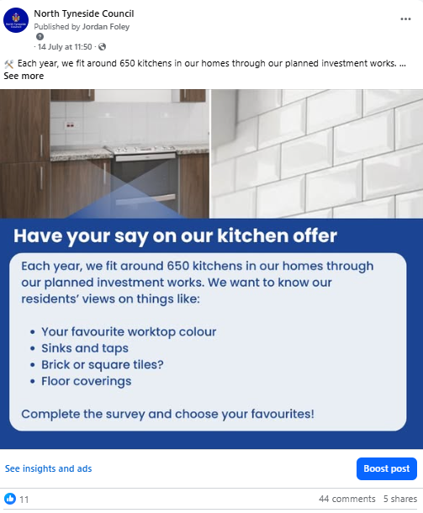

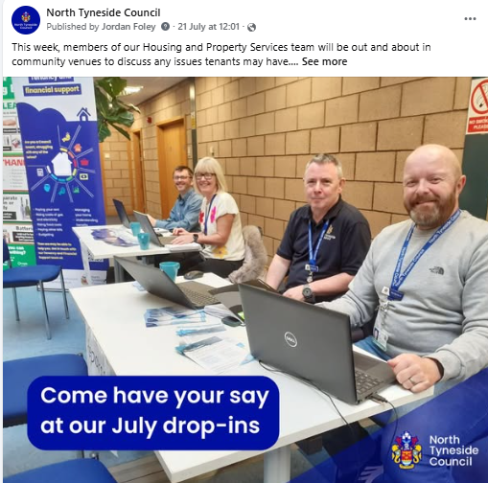

Kitchen consultation Tenant drop-in sessions
14 July 21 July
Post reach: 31,872 Post reach: 44,332
Interactions: 66 (likes/shares/comments) Interactions: 104 (likes/shares/comments)

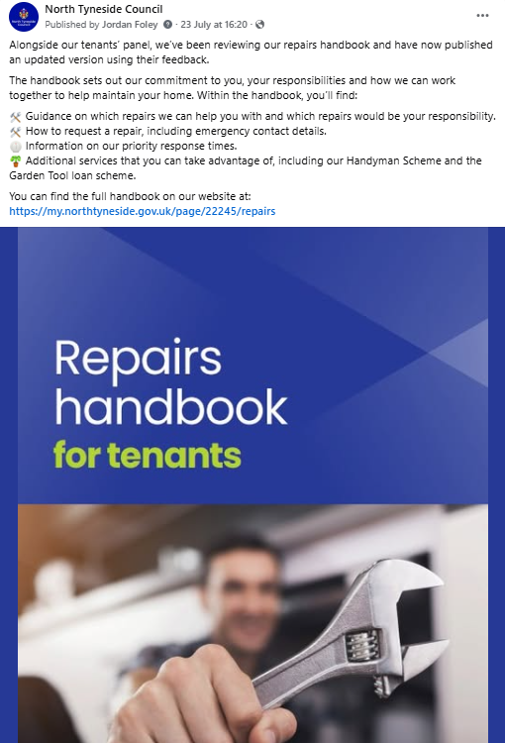
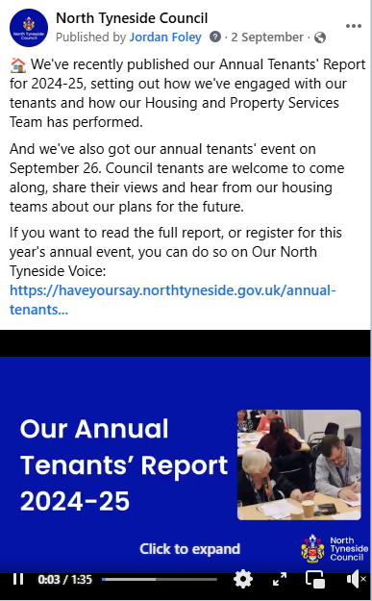

New repairs handbook Annual report
23 July 2 September
Post reach: 8,726 Post reach: 1,632
Interactions: 16 (likes/shares/comments) Interactions: 17 (likes/share/comments)

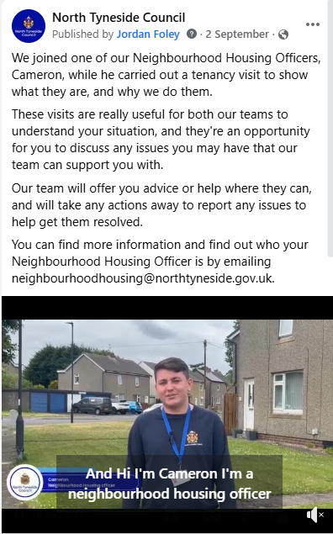
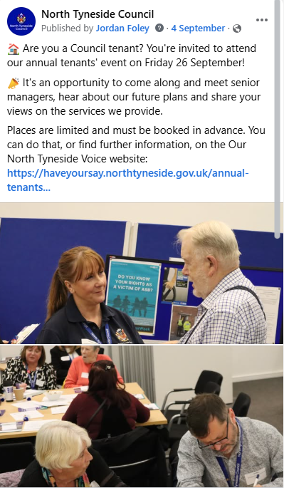

Tenancy home visits video Annual event sign-up
2 September 4 September
Post reach: 7,622 Post reach: 18, 256
Interactions: 78 (likes/shares/comments) Interactions: 77 (likes/shares/comments)
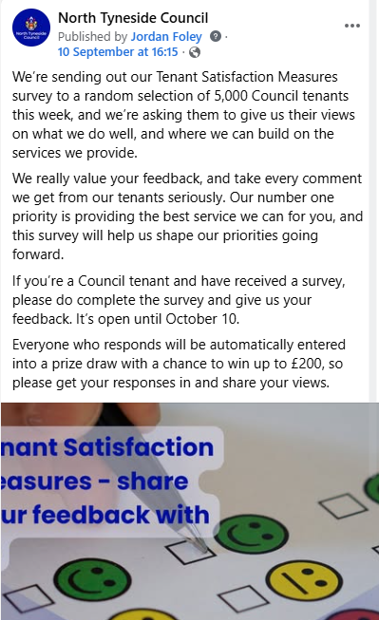
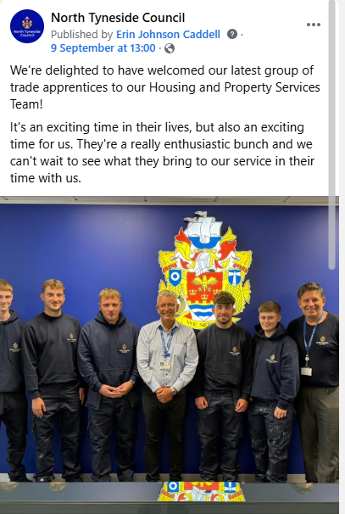

Trade apprentices TSM survey
9 September 10 September
Post reach: 66,576 Post reach: 4,236
Interactions: 264 (likes/shares/comments) Interactions: 8 (likes/shares/comments)

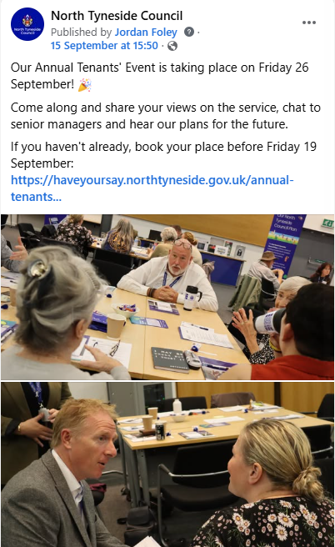
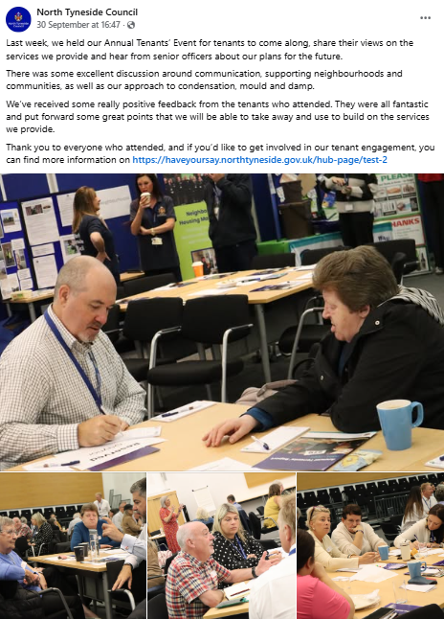

Annual event sign-up reminder Annual event photos/ONTV promotion
15 September 30 September
Post reach: 16,488 Post reach: 18,940
Interactions: 75 (likes/shares/comments) Interactions: 91 (likes/shares/comments)

10. Actions for October-December

- Winter drop-ins: Thursday 27 November at Shiremoor Library; Saturday 29 November at Wallsend community hub and library; Tuesday 2 December at John Willie Sams. We will have team members from Repairs, Tenancy and Financial Support, Homefinder/allocations, Neighbourhoods and Community Protection, along with a colleague from environmental services after several grass/trees/weeds queries at the summer drop-ins.

- Publish the Tenant Engagement Strategy, subject to approval at Cabinet.

- Arrange a task and finish group with tenants to review the empty homes process.

- Our next round of tenant panel meetings are as follows:
- NTL Panel: Thursday 13 November
- Landlord Panel: Wednesday 26 November
- Estates and Communities Panel: Wednesday 19 November
- Repairs and Investment: Tuesday 25 November
- Leaseholder Panel: TBC

