 | Planning — 1st Floor Left Quadrant East  The Silverlink North Cobalt Business Park North Tyneside  NE27 OBY
North Tyneside Council

HOUSEHOLDER EXTENSIONS & ALTERATIONS PRE-
PLANNING APPLICATION ADVICE FORM
Planning 1st floor left,
Quadrant East, The Silverlink North
Cobalt Business Park, North Tyneside
NE27 OBY
If you are proposing to enlarge or alter your dwelling or erect a building (other than a new house) within the boundary of your dwelling and have already established that you require planning permission, it is advisable to obtain pre-application advice prior to submitting a planning application. A fee is charged for this service. Please refer to our Pre-Planning application advice leaflet for details.
Please note that the pre-planning advice service cannot be used to determine whether or not planning permission is required. An application for a Certificate of Proposed Lawful Development must be submitted if you wish the Local Planning Authority to provide this information.
Please complete and return this form to us to find out whether your proposal is likely to gain planning approval. If you have any problems in completing this form please telephone 0191 643 2310 or email: development.control@northtyneside.gov.uk
It is worth reading Section 5.11 of the Design Quality Supplementary Planning Document before you submit this form. This gives advice on residential extensions. It is available to view on our website (www.northtyneside.gov.uk).
If you have already applied for planning permission for your proposal or a similar proposal please give the reference number if known.
Ref. No. / /
Applicant Name and Address:  Telephone No:  Email: | Agent Name and Address:  Telephone No:  Email:
Address of property to be altered:

Type of property:
House ❑ Flat ❑ Terraced ❑ Semi-detached ❑ Detached ❑
Bungalow ❑
Description of proposed development including dimensions (in metres):

Using the following examples for guidance, please provide sketches on the following blank page to show your proposed extension:
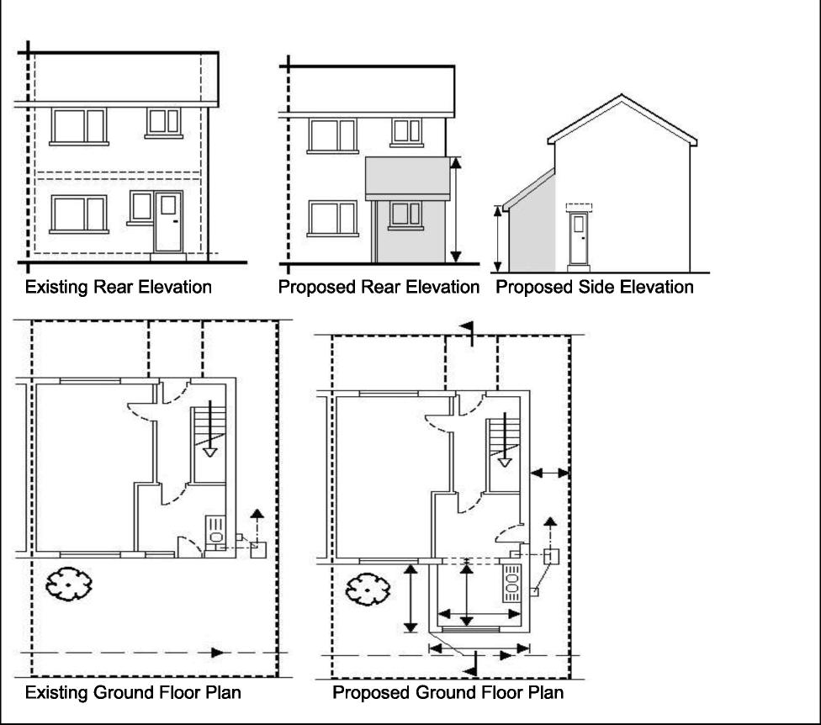
Sketch Plan:
North Tyneside Council wants to ensure that its services are as easy to use as possible through their Fair Access Policy. All forms and guidance notes for making a planning application will be made available in minority ethnic languages, Braille, audiotape, large print or other format as requested.
If English is not your first language and you would like information about this document please contact North Tyneside Council at the Quadrant East, The Silverlink North, Cobalt Business Park, North Tyneside, NE27 OBY . Telephone: 0191 643 2310 You can visit the Council web site at: www.northtyneside.gov.uk
- ?t1:4 Tio4:" 3n_,-;1Ft Tr 74 , 19-1(4 uirrtit cal bt',g er747e.
277 0.'r.f-77471776 ;lit tt .-Nh'1,717, tr! u '3%15
1,1cath Tvreside i.,ruachant, The Sth.rer.....11*-....k. North, F'arh
North Tvreside, 1-.1E.27 CIBY
r_NT41,,,P4 r—,..,[;$77Ff; 0191 643 2310
1-1,11;;IC.;1•1'6: Ih w wm-ttntrifityucAidtl. tt DV. uk 6'44 T,.1,4ti c'11 7
NOgf ;10911-5h11 nuk ei.hte giutia JLA -Lrflu{rC dht.: no iiitbrrro-ra licihur rnti kag
dokurtient. Iu luternF konLadon.: rcip hkotil Tvrt,sult: Gotirwil 14,4st-ilk North Tvriesidal
ldortl Tyreside (:!ourcil, Quadrant, The Silverlink North, Gcbalt Birthea3F'-ark
1-1cath TyresidF.,, NE27 OBY Telefoni 0191 x;432310
N1.181-S0 '.'ireb site' in ukuslrillii rr lure' to Idtitoni le 9d Pilo:
ruarthtyne ,da.gov.uk
liaffAtT4ITJP.TiVittjcitOV43.40c140M1t*MEVA
( North Tyneside Council ) fiL Quadrant, Tie S North,
Ccbalt Eoriress F'arE North Tyneside. NE27 MY
,Tic :0191 643'!311.1
?-1) ff 41_ w • www.narthtyneside.gov uk
1.1.1 s:3'24). 11.4.1_4 -WA Lifai ALS 1.1' Lag
:L721:1 leJLari: Alst
Tyi.E.; C ouncil, Silverlinl: North, alt Business Park, North Tyneside, NE27 OBY
,r4 ▪ 0191 643 2310 jint 4
4124 vow-wail:1'th Lyn esidt.7o-.
I-. J-rt-13-17Tatrt:1
A' :IA I3T021)_113-1r_J1
North Tyresrde t.ruadtaritile Sthjerlink. North, Ccball ▪ F'ark,
Noith T•,,rreside, OBY
71_41-si 24.'3: 0 19 1 643 -.J310
3r)-ifIPTF184.ratIi-VOL-ij
trionwikurthlyneSide.00v, Ilk
Equality Monitoring Form
Providing the information requested in this form is optional, however by providing it you will help North Tyneside Council to look at ways to improve its services to you. Information you give is recorded anonymously by the Council and used for monitoring. Your personal details will not be shared with any other organisations. If you have any queries please contact 0191 643 2310.
Gender: ❑ Female ❑ Male
Age: ❑ Under 18 ❑ 18-24 ❑ 25-34 ❑ 35-44
- 45-54 ❑ 55-64 ❑ 65-74 ❑ 75 or over
Ethnic Origin:
White: ❑ White British ❑ White Irish ❑ Gypsy/Traveller ❑ Any other White background
Black or Black British: ❑ Caribbean ❑ African ❑ Any other Black background
Asian or Asian British: ❑ Indian ❑ Pakistani ❑ Bangladeshi
- Chinese ❑ Any other Asian background
Mixed: ❑ White and Black Caribbean ❑ White and Black African
- White and Asian ❑ Any other Mixed background
Other: ❑ Arab ❑ Other ethnic group, please state:
Sexual Orientation:
- Bisexual ❑ Gay or lesbian ❑ Heterosexual ❑ Prefer not to say
Religion / Belief: ❑ Buddhist ❑ Christian denominations ❑ Jewish
- Muslim ❑ Sikh ❑ Hindu
- Prefer not to say ❑ None ❑ Other, please state:
Do you consider yourself to be a person with a disability? ❑ Yes ❑ No
Are your day-to-day activities limited because of a health problem or disability which has lasted, or is expected to last, at least 12 months?
Are you responsible for caring for anyone? ❑ Yes ❑ No
Do you look after, or give any help or support to family members, friends, neighbours or others because of long-term physical or mental ill-health / disability, or problems related to old age? (Do not count anything you do as part of your paid employment)
Marriage and civil partnership status
- Never married or registered a same-sex civil partnership ❑ Married
- Separated, but still legally married ❑ Divorced ❑ Widowed
- In a registered civil partnership ❑ Separated, but still legally in a civil partnership
- Formerly in a same-sex civil partnership which is now legally dissolved
- Surviving partner from a same-sex civil partnership
Thank you

