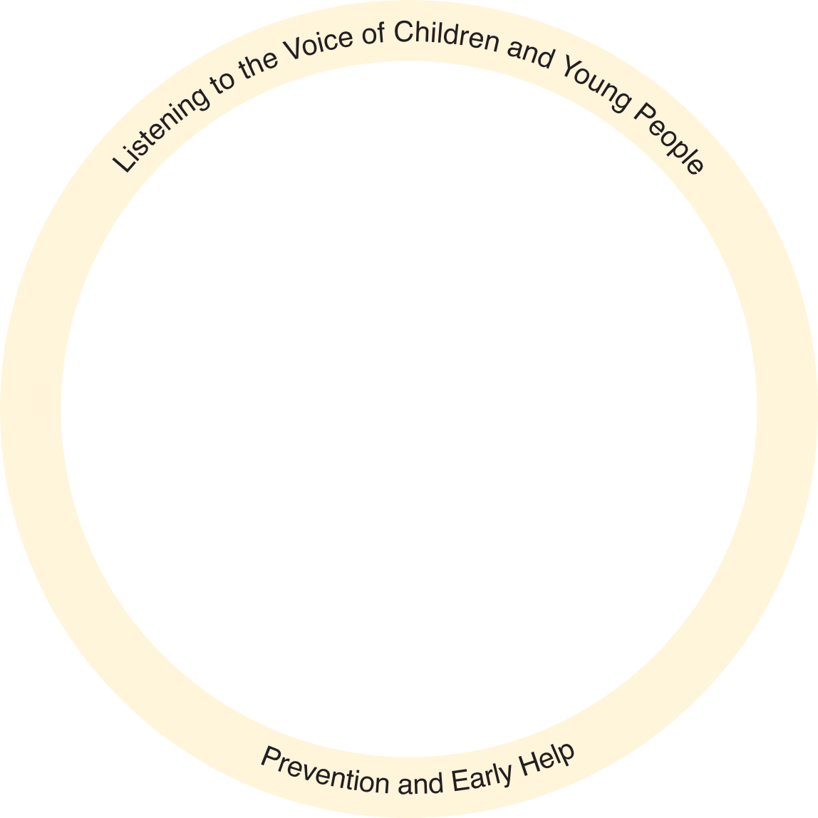


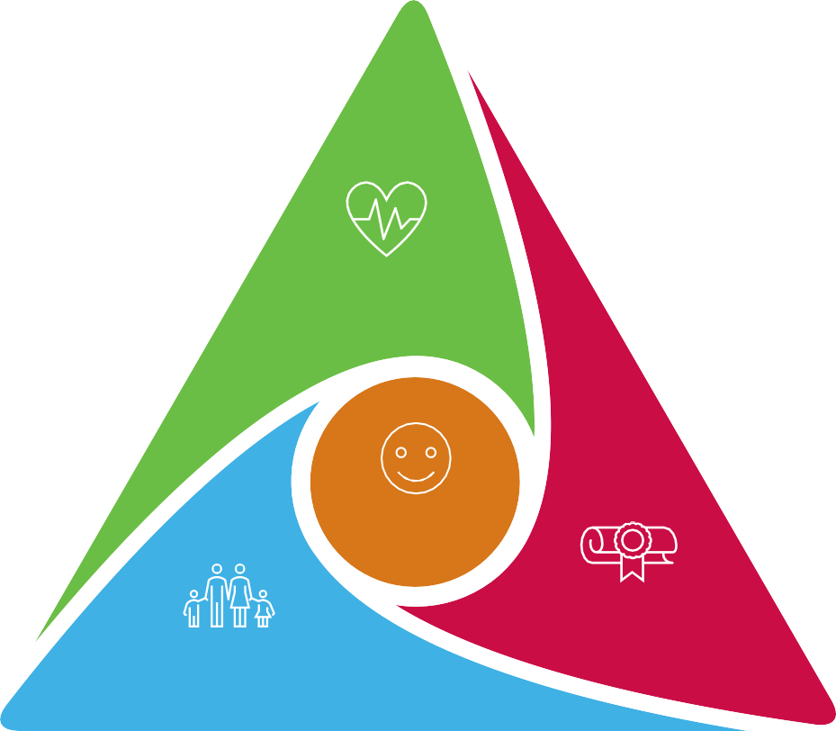

Prevention and Early Help in North Tyneside form the foundations of our support to children, young
people and families across the Borough. They play a critical role in helping us achieve our vision,
and the outcomes that we want to see for all children and young people across the Borough.
This strategic position statement has been developed to reflect our continuing commitment and
ambition to ensure we deliver the right support to families at the time they need it. Our work is
underpinned by our shared principles, that in all aspects of our work, we will listen to the voices of
children and young people, as we continue to embed our prevention and early help agenda
across all our strategies and plans.
These key services also align entirely with our three pledges to children and young people, that we
will intervene early with evidence-based, family focused services, we will work in partnership to
keep children in school and we will keep children and young people safe at home, healthy and
connected to their networks and local communities. We understand the critical importance of
prevention and early help in narrowing inequalities for our children, families and their communities
and in creating opportunities for all children to thrive and maximise their potential throughout
their childhood.
We are proud of the partnership working that has driven
improved outcomes and service innovation in terms of the
support we are able to provide for our families. We could not
have achieved this without having maintained the mature and
effective partnership relationships that exist in North Tyneside.
Alongside this we value our trusted relationships with children,
young people, families and communities. We know the
difference strong and trusted relationships can have. It is these
relationships that have helped us to ensure that early help is “everyone’s business”.

Achieving
Based on our 2021-2024 EH strategy we have...
Continued to | Supported our children | Established a route | Established a | Established a bespoke Early Help offer for young carers. | We have | Enhanced our | Increased offer to | Produced an | Enhanced our
develop a | to do better than ever at | for EH support for | graduated response | Established a bespoke Early Help offer for young carers. | co-produced and | response from | support domestic | attendance | offer with
whole family | the end of reception and | families referred | through the work of the | Established a bespoke Early Help offer for young carers. | launched our Early | MASH with all | abuse through | policy and piloted a | Housing Services
early help | currently doing better than | into CAMHS - 98% of | Emotional Wellbeing | Established a bespoke Early Help offer for young carers. | Years Inclusion | police notifications | commissioned | new joint approach | through
approach to | the national average in | families supported | Strategy which is | Established a bespoke Early Help offer for young carers. | Service, focussed on | through early help. | services. | to low attendance, | dedicated DA
supporting | relation to achieving | by Early Help did not | developing new | Established a bespoke Early Help offer for young carers. | identifying all C&YP |  |  | which we are | workers.
children with an | Attainment 8. We are at | need a further | pathways, enabling | Established a bespoke Early Help offer for young carers. | who have or may |  |  | continuing to
EHCP. | both the expected level | CAMHS intervention | families to access | Established a bespoke Early Help offer for young carers. | have SEND under 5 |  |  | develop.
 | and higher greater depth |  | support through schools | Established a bespoke Early Help offer for young carers. | years of age.
 | standard for KS1. |  | and their community. | Established a bespoke Early Help offer for young carers.

The strategic context

The Our North Tyneside Council Plan outlines a vision of building a better North Tyneside looking to the future; and listening to and working better for residents. The plan features five themes that reflect your priorities aimed at creating a North Tyneside that is thriving, family-friendly, caring, secure and green.

The following documents align to the family-friendly theme of the Our North Tyneside Council Plan and provide a strategic framework for Early Help services in the borough:

Our model



















Our model within Prevention and Early Help is based on the belief that building trusting relationships, providing the right support at the right time and in the right place, will help keep children and young people safe within their families, networks and communities.
Prevention and Early Help Offer
Employment and Financial
Early Help Practitioners
Housing
Support
Family, networks,
Police
and local community
Health Visitors and Antenatal Support
The Child
Midwifery and Perinatal Support
SEND
Support
Domestic Abuse Services
Public Health
VCSE
School Nurses
Mental Health and Emotional Wellbeing Support
- North Tyneside Children and Young People’s Plan

Our pledges
We intervene early with evidence based, family focused services.
We work in partnership to keep children in school.
We keep children and young people safe at home, healthy
and connected to their networks and local communities.
- Special Educational Needs and Disabilities Inclusion Strategy
- Children and Young People’s Mental Health and Emotional Wellbeing Strategy
- Equally Well: A healthier, fairer future for North Tyneside
- North Tyneside Alcohol Strategy
- North Tyneside Autism Strategy

Priority outcomes
A Safe Life
A Healthy Life
A Happy Life
Achieving in Life
- North Tyneside Domestic Abuse Strategy
- Joint Forward Plan
- North Tyneside Youth Justice Plan
- Connecting Communities A Strategy for Community Hubs and Libraries 2023 – 2028

Our agreed strategic vision
Make North Tyneside an even greater place for children and young people to thrive; where all, including those who are vulnerable, disadvantaged, or disabled, are ready for school, ready for work and life, cared for and supported.

Between 2024 – 2028 based on the strategies above we will...
Deliver the Best | Develop and | Reduce | Working together to | Delivery of the partnership's | Work in partnership to deliver the longer | Work in | Increase parent and carer | Embed the
Start in Life | embed the new | inequalities | improve school | Neurodiversity Transformation | term vision of the wellbeing strategy, | partnership so | awareness of guidance around | Graduated
priorities, | Early Years | affecting | attendance and | Programme, creating a | to further improve children and young | children and | alcohol consumption during | SEND Approach
focused on the | Inclusion Service | families across | attainment, as part of | needs-led approach with the | people's emotional health and | young people are | childhood and adolescence, to
first 1001 critical |  | the borough | the Ambition for | right support available at the | wellbeing, where those who are | protected from | minimise negative impact including
days |  |  | Education Strategy | right time, across education, | neurodivergent live in neuro-comfortable, | the effects of | the reduction of alcohol-specific
 |  |  |  | health, and care | inclusive communities | domestic abuse | admissions for under 18s

