New Pavement Licence Application Form
Business and Planning Act 2020
Date received |  | App no. | PLICTC
Fee paid |  | Receipt no.

North Tyneside Council
Licensing Team
Block A
Harvey Combe
Killingworth
NE12 6QQ

Please read before completing

- This form must be completed in full and submitted along with all the required supporting information via email to liquor.licensing@northtyneside.gov.uk Failure to do so will mean that your application can not be accepted.

- The associated fee can be paid by BACS transfer using the details in Part F.

- It is recommended that you talk to neighbouring businesses and occupiers prior to applying for a licence so that you can take potential noise and nuisance issues into account in your proposal.

- The application will be subject to a public consultation period of 14 days (excluding Bank and Public holidays) starting on the day after a valid application is made. Once the application has been processed by the Authority, it will be advertised on the Authority’s website.

- You must, on the same day the application is made, fix a notice of the application to the premises so that it is readily visible to members of the public who are not on the premises. You should be able to provide evidence that you have done this. The notice must remain in place until the end of the consultation period. A template notice is available on the Authority’s website.

- The Local Authority has 14 days to consider and determine the application after the consultation. The determination period is 14 days beginning with the first working day after the end of the public consultation period.

- If granted the licence will be valid for a maximum duration up to two years.

- The grant of a pavement licence only permits the placing of furniture on the highway; other regulatory frameworks still apply such as the need for alcohol licences and the need for food business registration.

- A granted pavement licence will be subject to conditions. These may reflect those set out in the Business and Planning Act 2020, those published by the relevant Secretary of State, and local conditions set by the Authority.

- If an applicant breaches any condition of the licence, then the Authority may revoke the licence or serve on the licensee a notice requiring the taking of such steps to remedy the breach as specified in the notice within the time specified. If the breach is not remedied, then the Authority may revoke the licence or take the steps itself and recover the costs of doing so from the licensee. The licence may also be revoked if all or any part of the area of the highway to which the licence relates has become unsuitable for any purpose for which the licence was granted or as a result of the licence there is a risk to public health or safety; anti-social behaviour or public nuisance is being caused or risks being caused; the highway is being obstructed (other than by anything done by the licensee pursuant to the licence); anything material stated by the licensee in their application for a licence was false or misleading or the licensee failed to properly fix a notice of the application to the premises so that it could be easily read and ensure that such notice remained in place until the end of the 14 day consultation period.

- If you have a premises licence (Licensing Act 2003) allowing the sale of alcohol you must ensure that the premises licence includes ‘off’ sales of alcohol otherwise customers shall not be permitted to consume alcohol in the Pavement licence area. (Government is currently carrying out a consultation which may change this in the future.)

- If you have any queries filling out the application form or need us to do anything differently (reasonable adjustments) to help you access our services, including providing this information in another language or format, please contact liquor.licensing@northtyneside.gov.uk or telephone 0191 643 2175.

Part A | Application Details (this can be a person or company)
Title:
Name:
Address:
Postcode:
Tel:
Email:
Company number (if applicable):
Does the applicant have day to day control of the business? Yes / No (delete as appropriate)

Is the applicant the freeholder/leaseholder or owner? Yes / No (delete as appropriate)

If the leaseholder, please provide the name and address of the freeholder:

Part B: | Business Premises Details
Business/Trading Name
Business Address:
Postcode:
Part C: | Proposed Use Of The Highway
Only businesses which use premises for the sale of food or drink for consumption on or off the premises can apply for a licence.
Please indicate the purpose(s) for which the pavement licence is to be used? (tick as appropriate)

Use by the licence holder to sell or serve food or drink
Use by other people (e.g. customers) for the consumption of food or drink sold by the premises
Both of the above

How long do you want the licence to be in place for? (Maximum 2 years)

Type of Furniture | Proposed Number Of items
Tables:
Chairs:
Barriers:
Parasols:
Planters:
Other furniture:  (please specify) | Advertising boards are not included in the definition of furniture within the pavement licensing regime, therefore should not be used as a barrier.
Please provide a description and photos of the proposed furniture. Furniture must be easily removeable
so that it can be stored away at the end of the licensed period.

Plan of Proposed Licenced Area
You must submit a plan and photograph showing the proposed pavement licence area in relation to the premises together with dimensions so that the application site can be clearly identified.
The plan must include the following information:
- The location of the premises and the proposed licensed area. The location of the proposed pavement licenced area must be clearly marked by a red line;
- The position of your premises in relation to other premises;
- The width and depth of the proposed licenced area;
- The location and distance between any existing street furniture and the proposed licensed area (e.g. bin, lamppost, railings);
- The proposed layout of the removable furniture
- The distance between the edge of the proposed licensed area and the kerb. A clear pedestrian route must be maintained for those walking past the premises. This would normally not be less than 2 metres in width.
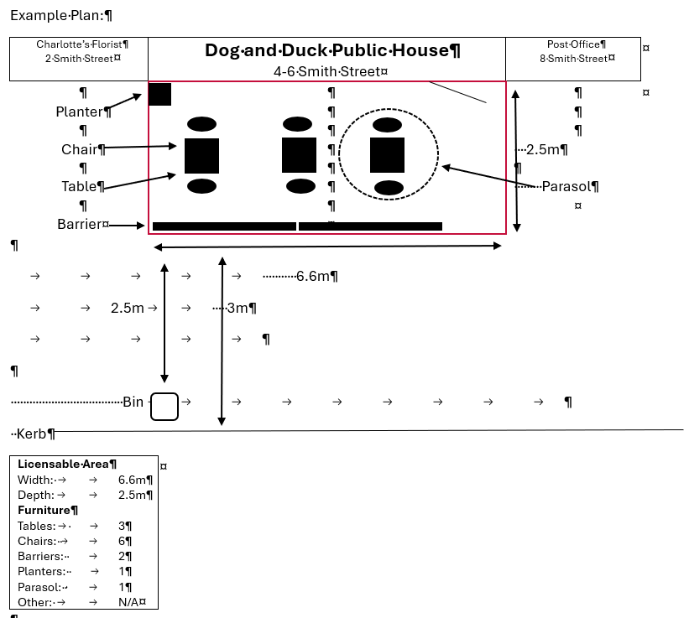
Dimensions Of Proposed Pavement Licence Area In Metres
Width (m) | Depth (m) |  | Available remaining space between proposed licensed area and edge of kerb (m)
During which times (between 08:00 – 21:00 only) do you propose to place removable furniture on the highway? Please use 24 hours clock.
Mondays | to |  |  |  | Friday | to
Tuesday | to |  |  |  | Saturdays | to
Wednesday | to |  |  |  | Sundays | to
Thursday | to
Where will the pavement licence furniture and other items be stored outside the licensed period?
All items must be removed from the highway.

How will the boundary of the pavement licensed area be defined? Please provide details of the fencing or barriers, if any, to be used as a boundary.

Part D | Premises Licence Conditions
Please describe how you intend to mitigate any noise or disturbance from customers using the proposed pavement licensed area to the occupiers of nearby commercial and domestic properties.

Please describe how you intend to ensure the public highway is not obstructed nor pedestrians inconvenienced by the additional furniture you propose to put on the public highway.

Please describe how you intend to ensure no one smokes inside the pavement licensed area.

Part E | Details Of Public Liability Insurance
Applicants must have a public liability insurance policy covering the external seating area for the whole of the proposed licence period. The amount insured must be at least £5 million. A copy of the policy must be submitted with the application.
Insurance Company:
Policy No:
Start Date:
Expiry Date:
Amount insured:
(must be at least £5 million)
Additional Information (optional)

Please provide any additional information you think relevant to this application

Part F | Application Fees
The information below sets out the licence fees for a maximum two-year period.
New Licence Application Fee |  | £146
Renewal Application Fee |  | £102
Payments to be made to:
Account Name: North Tyneside Council
Bank Name: Barclays Bank PLC
Address: 49/51 Northumberland Street, Newcastle –upon-Tyne, NE1 7AF
Sort Code: 20-59-42
Account No: 43141551
IBAN No: GB95 BARC 2059 4243 1415 51
BIC No: (Swift) BARC GB22
Remittance address: North Tyneside Council
Income Management Section
Cobalt Business Park
Silverlink North
North Tyneside
NE27 0BY
E-mail address: remittances@northtyneside.gov.uk

Indemnity

North Tyneside Council shall be indemnified against any claims, actions, proceedings or loss or damage arising as a result of any licence which may be granted in respect of the application.

Checklist

Please ensure you have attached the following:

- Plan of the proposed licensed area;
- Photos of the proposed area;
- Photos of the proposed furniture;
- Insurance document;
- Proof of licence fee payment

Declaration

I certify that:

- All information set out in this application is correct to the best of my knowledge and that I have not wilfully omitted any necessary material;
- I understand that I am required to affix a public consultation site notice to the premises so it is easily visible and legible to the public on the day I submit this application to the local authority and I shall ensure that the notice remains in place for the 14 days;
- I understand that if granted the Authority’s published conditions and any other conditions considered to be reasonable by the Authority may be attached to my licence;
- I understand that the application fee payable is non-refundable if my application is refused or if any licence granted is subsequently surrendered, suspended or revoked;
- I understand that the application fee must be paid before the application will be valid;
- I understand that the licence will be valid for a maximum of two years or shorter period if appropriate.

Signed: |  |  |  | Date of Application:
Print Name:

