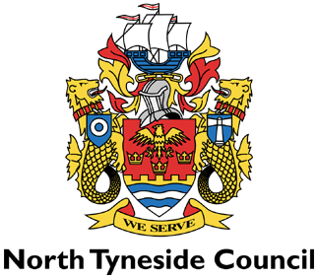

LICENSING ACT 2003

NOTICE OF APPLICATION FOR A PREMISES LICENCE

Premises | Northern Rye  Ground Floor, Unit 3  112 Little Bedford Street  North Shields  Tyne And Wear  NE29 6NW

Notice is hereby given that Dominic Vasseghi applied

on 27 November 2025 to North Tyneside Licensing Authority for a Premises Licence under the Licensing Act 2003.

The Licensable activities are:

Supply of alcohol: 07:00 hrs to 22:00 hrs daily.

Any representations to this application must be made in writing to: The Licensing Section, The Killingworth Site, Harvey Combe, Killingworth, Newcastle upon Tyne NE12 6QQ or by e-mail to liquor.licensing@northtyneside.gov.uk. Representations must

be received no later than 25 December 2025 (28 days after date application received by Licensing Section).

This application can be viewed at the above address between 9.30am and 4pm Monday to Friday or via www.northtyneside.gov.uk

It is an offence under Section 158 of the Licensing Act 2003, knowingly or recklessly to make a false statement in connection with an application and the maximum fine for which a person is liable on summary conviction for the offence is up to level 5 on the standard scale(£5000)

