
Advertising and Trading on the Highway – New Policy

It is recognised that shopping areas within North Tyneside have much to offer by way of creating a pleasant ambience attractive to shoppers and tourists alike.

North Tyneside Council recognises this and wishes to encourage traders to promote their business activities in a way that both enhances the street scene and is sensitive to the needs of its users.

In cooperation with the business community this policy which will provide a balance between the needs of highway users and the continuing need of businesses to promote themselves.

Conditions in relation to placement of A-Boards

- Only one A-Board shall be permitted per premises, even where the premises are shared.
- The Board must be capable of being easily removed i.e. require no excavation to install or remove.
- The board must not cause a visual distraction or obstruction to vehicle sight lines or block visibility for pedestrians.
- The board must be sympathetic in its positioning to the other aspects of the street.
- A minimum footpath width of 1.2m must be maintained.
- The board must be removed at the end of the trading day.
- The board will remain the responsibility of the owners when placed in the public highway and a permit for each board must be applied for with sufficient liability insurance.
- The board shall be sited immediately in front of the building frontage and must not be fixed to lampposts, bollards, seats or other street furniture.
- The board will be no wider than 600mm square in plan and no higher than 1000mm above ground level.
- The board must relate only to the activity of the business.
- Nothing within this policy absolves the owner from their legal responsibilities under the Highways Act 1980 and other legislation in any way other than allowing approved items on the public highway under the conditions listed.

Typical Photos of Obstructions caused by placement of A – Board
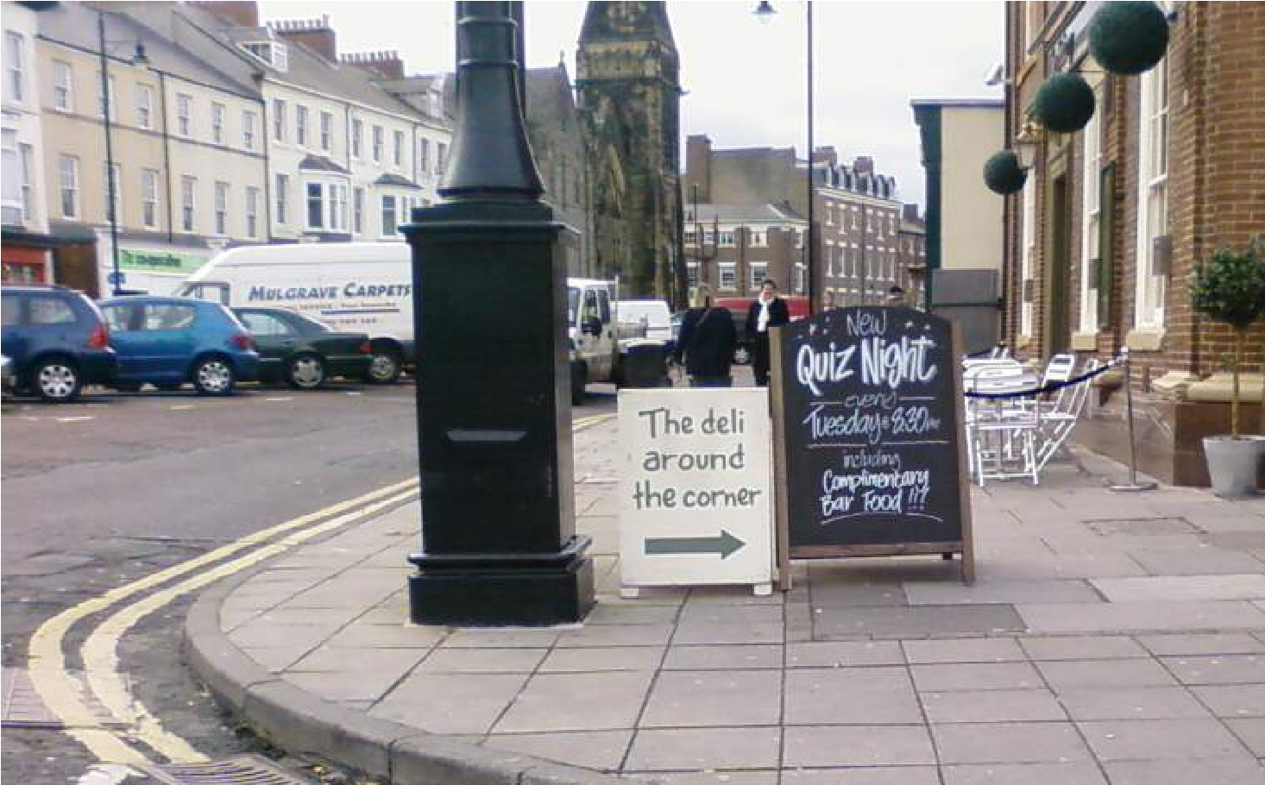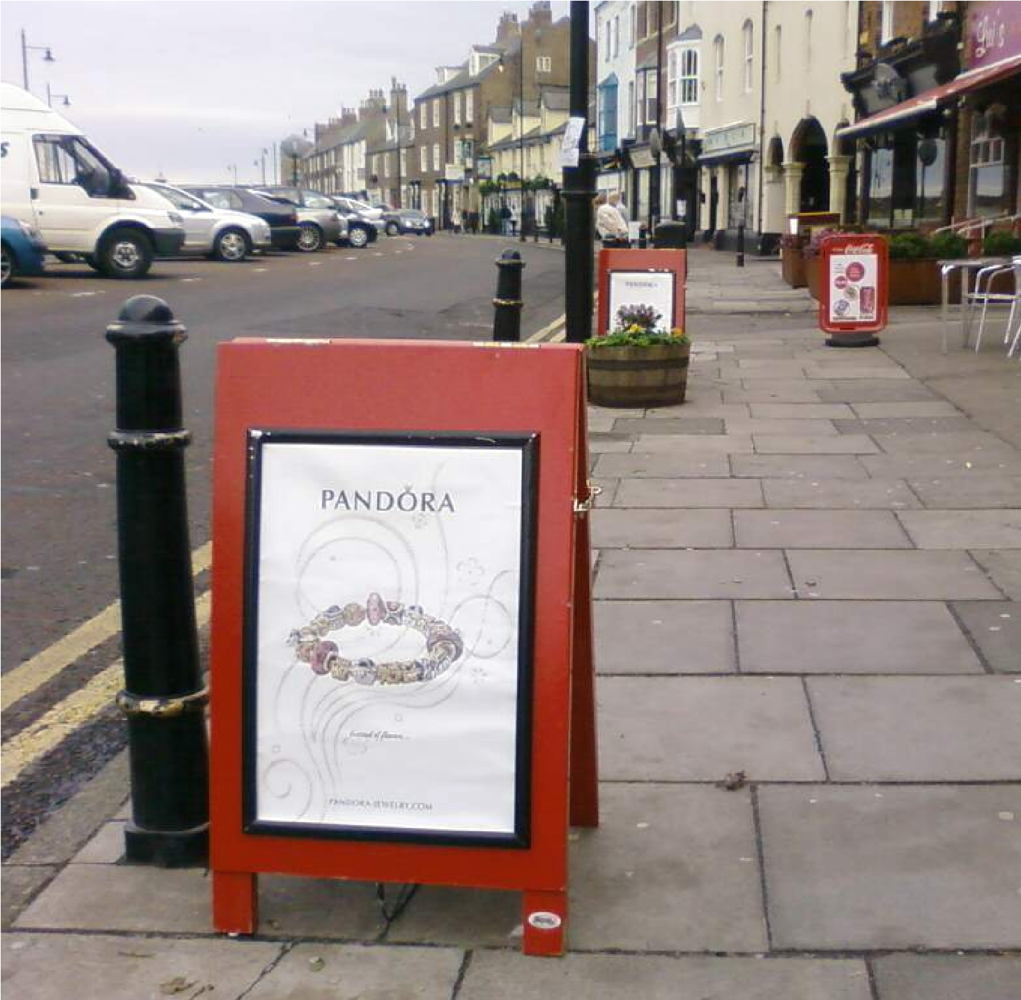

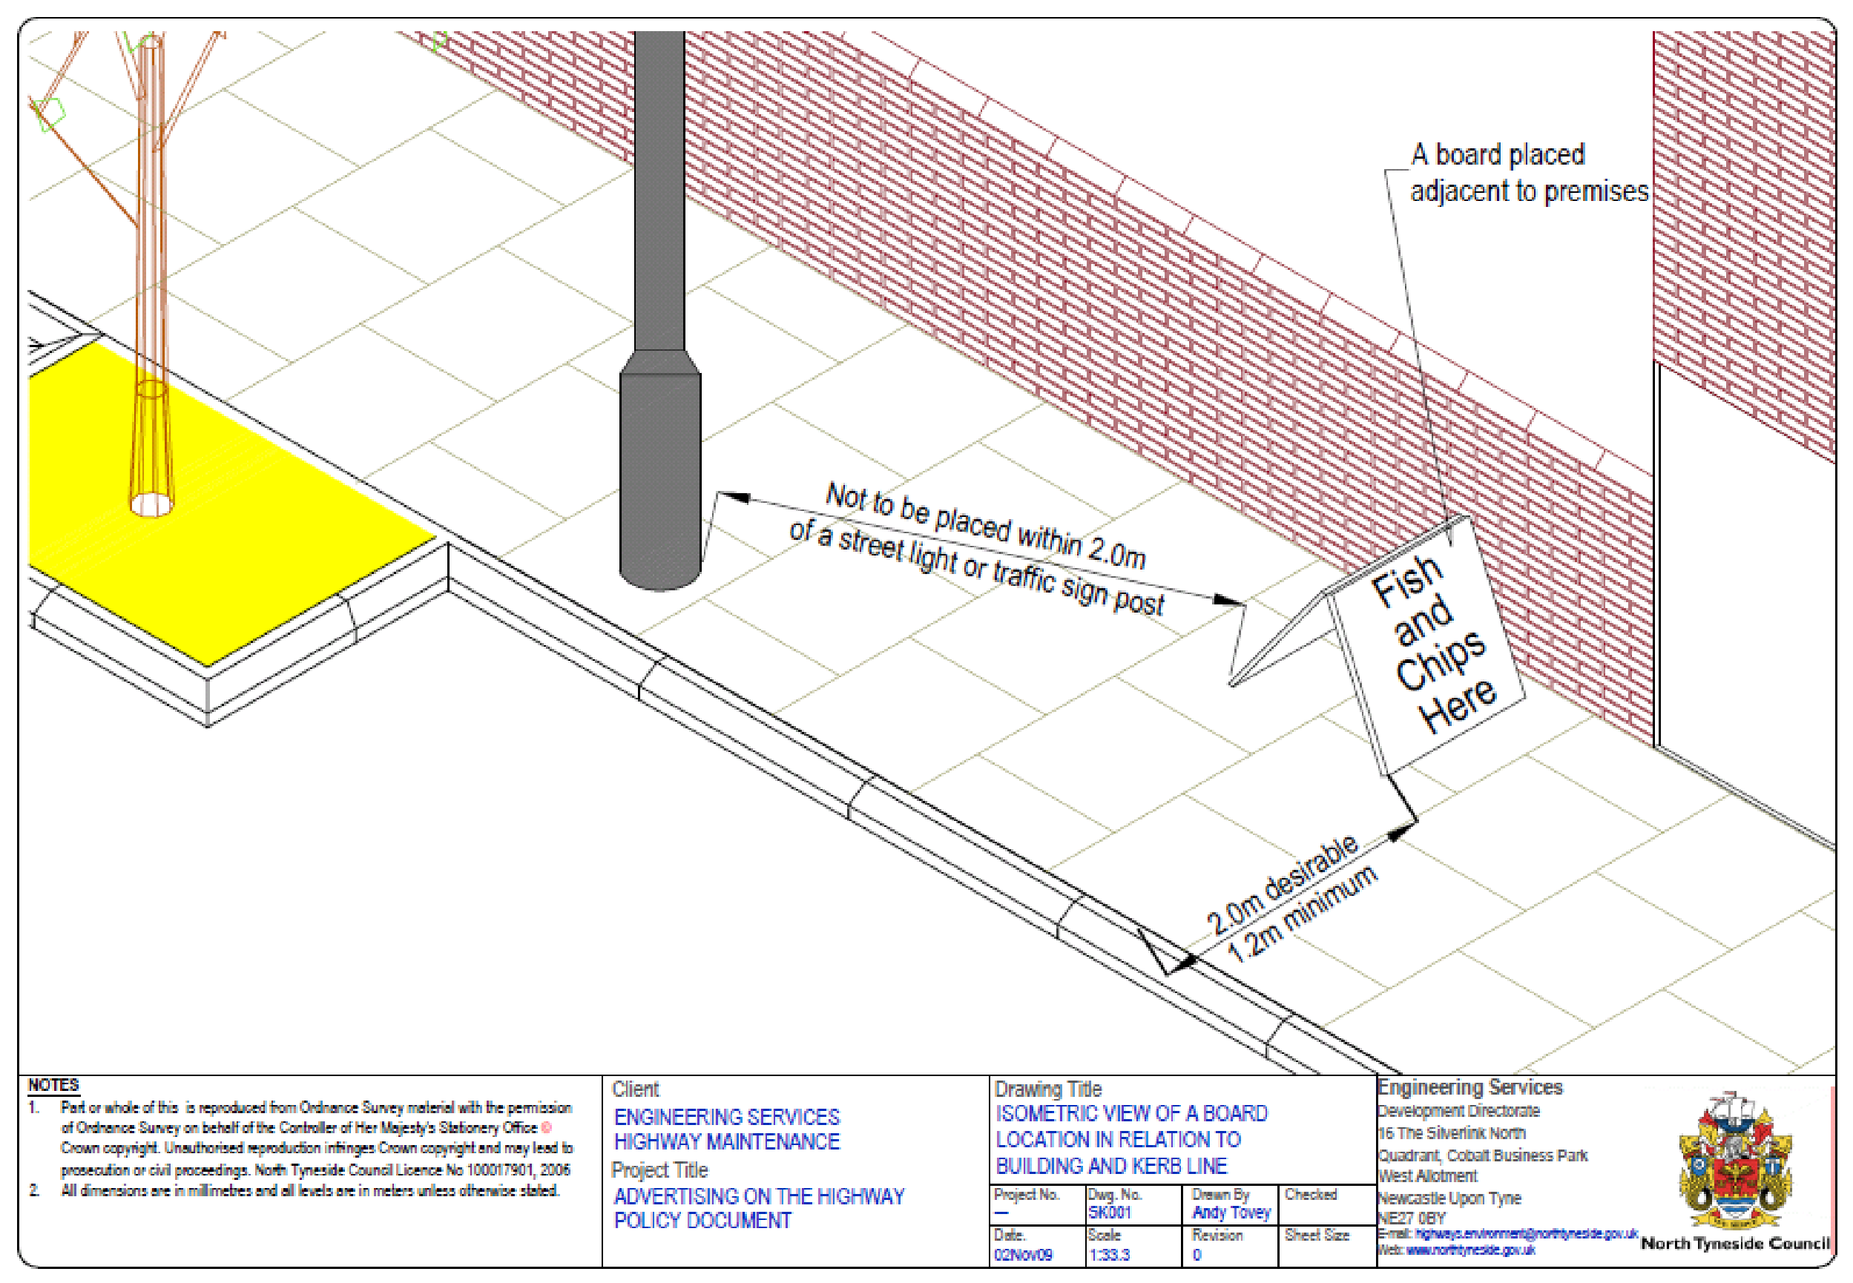

Conditions in relation to Placement of Goods on the Highway

- Displays should be located immediately outside the frontages of the business premises so that customers and staff are not crossing the flow of pedestrian traffic.
- The items on display should represent the goods for trade carried out normally at the premises.
- Goods displayed must not obstruct fire door exists, hydrants and utility apparatus such as stop taps and meters.
- Goods displays should match and harmonise with the surrounding environment and character.
- All displays should be no wider than 1.5m from the building line and in any event should not reduce the footpath width below 1.2m.
- Displays detached from the frontages will not be permitted
- Selling or trading will be permitted inside the premises only.

Typical Photos of Obstructions caused by placement goods on the Highway

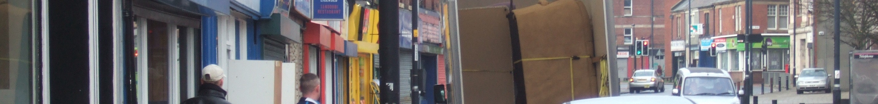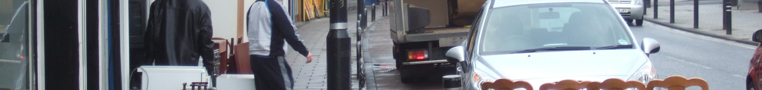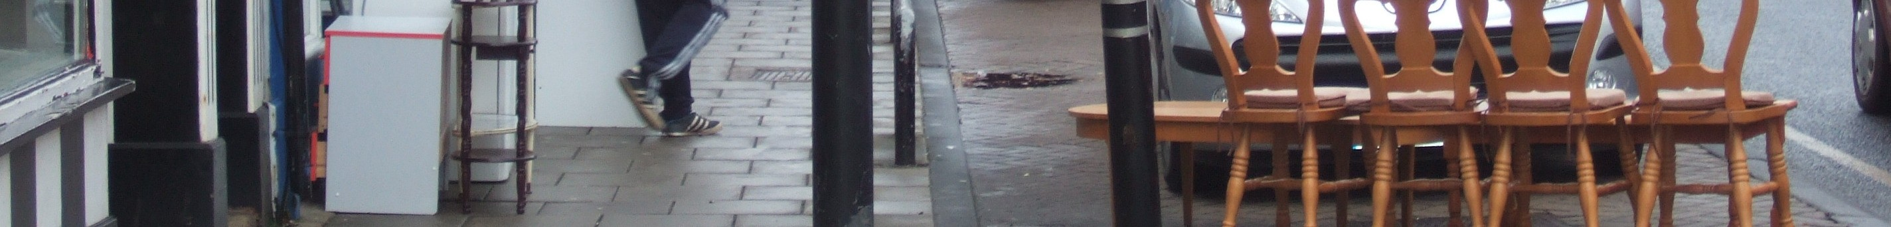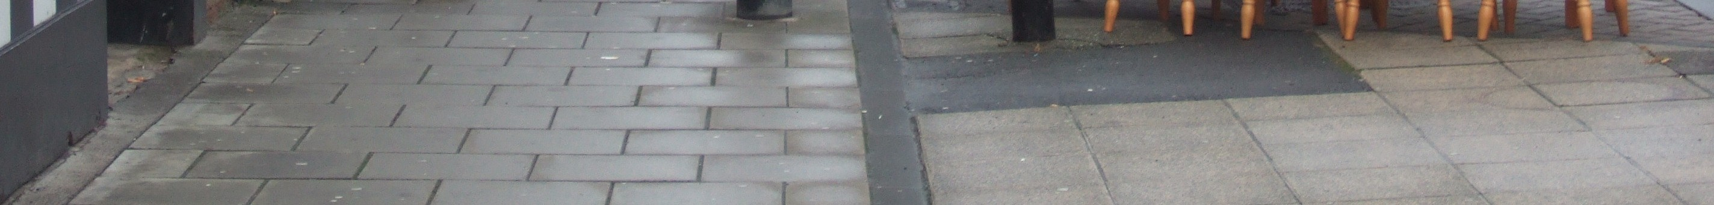

All completed forms should be sent to the Network Management Team by post, fax or email

North Tyneside Council
Regeneration Development and Regulatory Services
Network Management Team
First Floor Left
The Silverlink North
Cobalt Business Park
North Tyneside
NE27 0BY

Fax 0191 643 2426
Email: streetworks@northtyneside.gov.uk


A Boards Permit Application Form

Applicant Contact Details
Mr. Mrs. First name Surname
Ms.

Company/
Organisation……………………………………………………………………………………..

Address:…………………………………………………………………………………………… ……………………………………………………………Post Code:……………………………

Tel No:………………………………Fax No:………………………..

Email……………………………………………………………………

Emergency contact details
24hr Contact
Name:…………………………………………………………………………………

24hr telephone Number: ……………………………….Fax Number:…………………………

Email:………………………………………………………………………………………………
Name and Address of property owner/occupier (if different to Applicant)
………………………………………………………………………………………………………

………………………………………………………………………………………………………

……………………………………………………………………………………………………….

I/We hereby apply to position an A-Board, and agree to comply by the conditions stated in relation to the placement of goods on the highway

Proposed Start Date …………………  For one year | Permit Number ……………………………………

- Date of application ............................................................................................

- Signed ……………………………………………………………………………….......

