

1. Our North Tyneside Voice website
Tenant Engagement Report
Quarter 1: April-June
2025/26

As of 30 June, 600 tenants are registered on the Our North Tyneside Voice website.
Tenants are well represented on the site in general, making up 37% of those registered.

2. Tenant panels – May/June

The North Tyneside Living Panel heard updates on repairs target times from Morgan Sindall, opportunities for volunteering within the Victim Support service, and plans for the introduction of Unified. The TSM survey report had been shared and key points relating to NTL were highlighted. The panel also heard about new fire safety protocols, and the meeting ended with tenants agreeing to trial a change to the laundry service.

The Estates and Communities Panel received an update from Community Protection on actions to tackle anti-social behaviour. The main focus of this meeting was the Tenancy Home Visit process, tenants on the panel have previously provided feedback on the letters and name (it was changed from ‘Tenancy Reviews’ after their comments). The group also reviewed performance targets, the TSM results and the ‘good neighbour’ leaflet wording.

The Repairs and Communities Panel focused on a review of complaints for 2024-25 and how we are improving services from the feedback we receive. The panel also reviewed the TSM results and their performance scorecard, followed by a detailed look at progress on electrical safety inspections and stock condition surveys.

The Landlord Panel discussed the draft annual tenants’ report, with suggestions for additional detail or context. The panel then reviewed performance data – discussing lift safety checks, electrical inspections, communal block inspections, new tenant visits and home visit figures in more detail. This was followed by a complaints report and the meeting ended with an update on tenant engagement activities.

Leaseholder Panel: In March, we emailed around 300 leaseholders to gauge interest in this. Thirteen expressed interest and a Teams call was arranged in May, with five attending. Further consideration is needed as to how this could operate practically. There are currently insufficient numbers and there were clear differences between subjects of interest – eg those living in communal blocks compared to those in houses, and landlords who owned several properties. We will seek additional interest via the service charge letter going out shortly and then evaluate next steps. Those who attended were happy to be kept up to date as things develop.

3. April focus groups

Our tenant panels have previously considered the issue of ‘no access’. In addition, we wanted to get a group of tenants together to consider Unified in more detail – following up from the initial introduction to it at our September 2024 annual tenants’ event. These were run as separate sessions, on the same morning.

For the ‘no access’ group, 13 tenants considered why someone would deny us access to the property, what they think of our current process for requesting access and how they feel this could be improved. Feedback was extremely positive with tenants impressed with the figures and information provided, saying that it was very insightful and good to gain a better understanding of the impact of denying entry. A communications plan for an awareness-raising campaign has since been developed, with messages starting to go out in late June/early July and continuing over the coming months.

At the Unified group, 11 tenants heard an update on the project timeline, viewed proposed screen layouts, considered what support tenants may need and generated ideas for how we can best promote the system to tenants. Feedback from tenants was very good again, with comments on it having been extremely useful and informative.

More details can be found in the tenant area of the Our North Tyneside Voice website

4. Tenant drop-ins

Planning is underway for a second round of drop-ins, building on feedback from those done in January, at:
- White Swan Centre Community Hub and Library, Wednesday 23 July, 3-5pm
- Battle Hill Library, Saturday 26 July, 10am-12pm
- Cedarwood Trust, North Shields, Tuesday 29 July, 11am-1pm

Building on tenant feedback, we have included a Saturday session. Battle Hill and Killingworth have been selected as venues as results from our TSM survey showed that tenants in those wards were generally less satisfied – so this is an opportunity for us to engage directly with tenants in those areas.

These have been scheduled to allow for promotion in the summer issue of the council magazines, going to homes in July. It will also be highlighted on the council’s social media, the Have Your Say boards in our six Community Hubs and Libraries, on the Our North Tyneside Voce website, the VODA newsletter and local community groups. This time, we are doing more internal promotion with council services who have teams likely to see tenants as part of their role, eg the Health Visitors, Family Partners, Occupational Therapists, plus our housing repairs and neighbourhoods teams.
5. Tenants’ Annual Report 2024-25

This has been written with involvement of teams across the Housing and Property Service, with an early draft reviewed by our Landlord Panel. Their suggestions have been reflected in the final draft. This will go through for design work in July.

6. Young Tenants
A graduate trainee within the engagement team has been working closely with a small group of tenants and care-experienced young people to gain a better understanding of the challenges they face. This has led to a young tenant ‘handbook’ being compiled, which collates key information from the perspective of young tenants in an accessible way (it is not to replace any of the standard new tenant information they receive). Various colleagues within the housing service have been supporting this project. Some printed copies will be produced for the New Homes Team and Leaving Care Team, it will also be available online and via some of the local voluntary and community groups which support care-experienced young people.

7. Tenancy Agreement

A review of the Agreement was started last year, with a group of involved tenants. An updated draft was shared with tenants on our Estates and Communities Panel in June, with responses requested by early July.

8. Promotion

We are keen to include tenants in our future communications and have asked at our tenant panels for volunteers to be featured in videos or photos.

The summer issue of the council magazine will be distributed in July and includes:
- Details of our July drop-ins
- TSM results
- Tenancy home visits
- ‘No access’ awareness
- Estate walkabouts
- Unified awareness
- Garden care/garden equipment hire/bulky waste collections

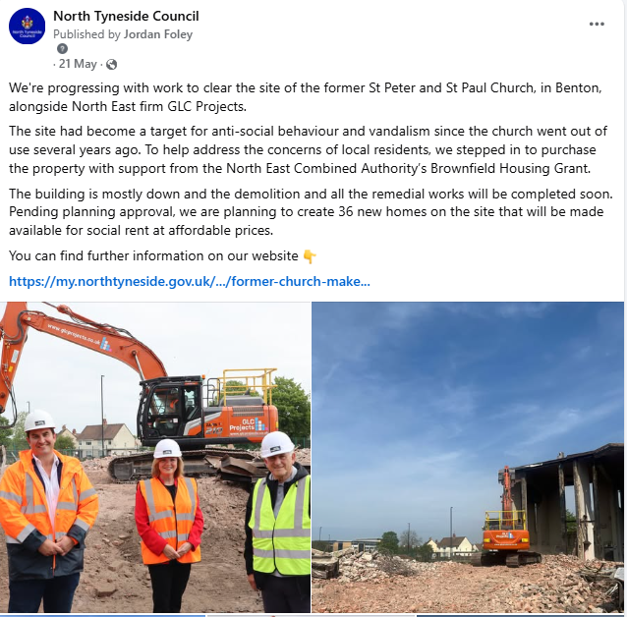
9. Social media
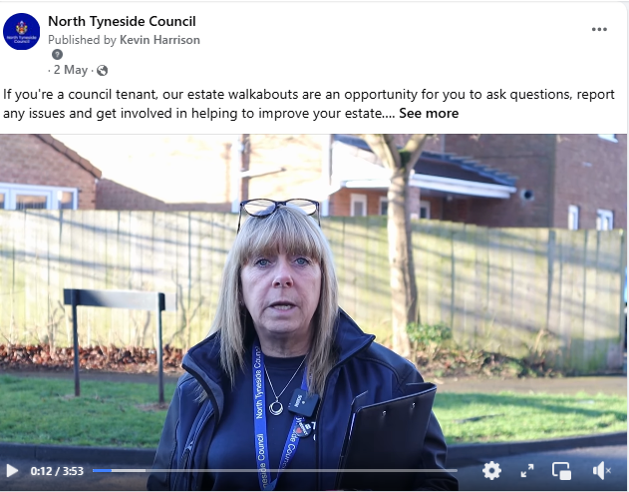
Estate walkabouts video St Peter and St Paul Church, Benton
2 May 21 May
Post reach: 19,080 Post reach: 8,487
Interactions: 157 (likes/shares/comments) Interactions: 102 (likes/shares/comments)

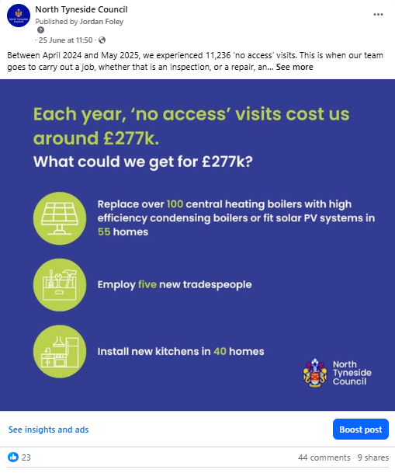
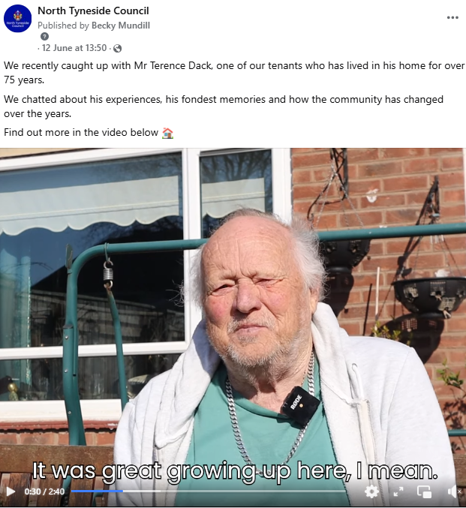

Terence, a tenant of 75 years video No access
12 June 25 June
Post reach: 9,880 Post reach: 30,637
Interactions: 115 (likes/shares/comments) Interactions: 83 (likes/shares/comments)

10. Actions for July-September

- July drop-ins: 23rd, 26th and 29th.

- The council’s annual Big Community Conversation is running from June-August. This is asking what people like about North Tyneside and what they would like to see improved. The demographic questions will include one asking whether the respondent is a council tenant, so we can filter the responses and use the results in our tenant programme. Results are expected in September.

- Consultation on revised kitchen options during July-August.

- Publish our Annual Tenants’ Report 2024-25.

- Promotion of Tenancy Home Visits, linking into wider work around ‘no access’.

- Consultation on a new Neighbourhood and Community Promise. This could draw in results of the Big Community Conversation, include work with tenants and community groups in target areas, and colleagues.

- Planning for our annual tenants’ event, to be held in the Chamber on Friday 26 September. We will involve our Landlord Panel in planning the session and will be asking our involved tenants to take an active role on the day.

- Seek additional leaseholder interest in a Leaseholder Panel, via the service charge letter.

- Public consultation on the draft Vulnerabilities and Reasonable Adjustments Policy and Aids and Adaptations Policy. This will be via the Our North Tyneside Voice website and promoted to residents and community groups working with people who may be classed as ‘vulnerable’. Paper copies will be available in the six community hubs and libraries. We will do both consultations alongside each other, as it is likely that similar audiences will be interested in both.

- Develop a new tenant engagement strategy, working with our Landlord Panel.

- Our next round of tenant panel meetings are as follows:
- NTL Panel: Wednesday 3 September
- Landlord Panel: Tuesday 9 September
- Estates and Communities Panel: Wednesday 10 September
- Repairs and Investment: Wednesday 17 September
- Leaseholder Panel: TBC

