Annual Local Highway Maintenance Transparency Report
Prepared by: Paul Mitchinson
For: North Tyneside Council
Date: October 2025

Introduction

This document has been produced by North Tyneside Council to support our annual submission to the Department for Transport (DfT) as part of the Local Highway Maintenance Funding 2025/26 incentive funding requirements. The purpose of this report is to provide a transparent, structured account of our current asset management processes, maintenance investment, performance monitoring, and forward planning.
It has been designed to meet the Annex B (technical assurance) requirements of the Incentive Fund guidance. The information presented reflects our local priorities, approach to risk-based efficient delivery of our highway maintenance, and our alignment with national codes of practice, including Well-Managed Highway Infrastructure (WMHI).
The content includes summary data on technical metrics such as gross replacement cost, asset value trends, and key performance indicators. Where relevant, we have also included additional information beyond the DfT’s minimum requirements to demonstrate added value and our commitment to continuous improvement.
This report has been prepared by the highways maintenance service in consultation with senior officers and relevant portfolio holders. As well as meeting DfT reporting requirements, it also serves to improve transparency for our stakeholders, elected members, and residents. By clearly setting out how we manage, maintain, and invest in our network, we aim to provide a consistent and evidence-based account of our activities and priorities, supporting ongoing accountability and engagement.

Annex B – Technical Assurance Report
Submission deadline: 31 October 2025
This section provides the Department for Transport with the technical evidence required to support our Incentive Fund submission. It includes detailed information on asset value, condition, investment, and performance to demonstrate how we manage our network.

1. Gross Replacement Cost / Asset Value of Highway Assets. The figure below presents our latest highway asset valuation, based on HAMFIG/CIPFA methodology.
Asset Valuation – 2025/26
£1,974.8 million
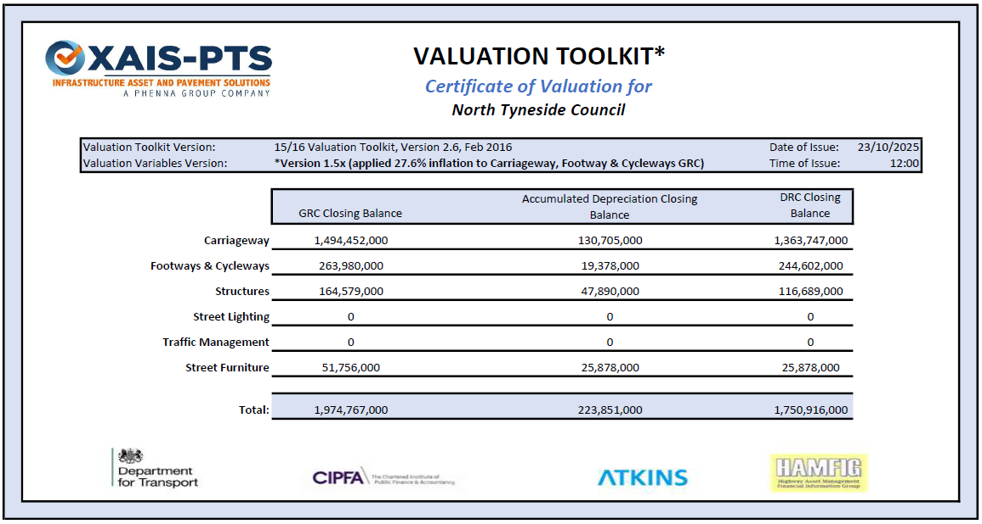
📝 Commentary – Gross Replacement Cost of Highway Assets:
The carriageway and Footway valuation is derived from the Annual Engineering Inspection (AEI) survey undertaken in 2024/25 (Footways 2023-25) and following the CIPFA guidance and templates on Asset Valuation and the Code of Practice on Transport Infrastructure Assets. The model rates have not been updated since 2018/19. Outputs from the HAMFIG/CIPFA model have been generated applying the Consumer Prices Index (CPI) inflation rate of 27.6% to the carriageway and to the Footway + Cycleway GRC values that are generated from the official CIPFA spreadsheet.

2. % of Asset Value Spent on Maintenance – Last Five Years
The tables below highlight the total maintenance spend as a percentage of Gross Replacement Cost (GRC), Depreciated Replacement Cost (DRC) and Annual Depreciation for current asset value over the last 5 years.
GRC
Year | Total Annual Maintenance Spend (£000s) | GRC (£000s) | % (of GRC) Maintenance Spend
2020/21 | £6,083 | £1,974,767 | 0.308%
2021/22 | £6,083 | £1,974,767 | 0.308%
2022/23 | £6,083 | £1,974,767 | 0.308%
2023/24 | £6,584 | £1,974,767 | 0.333%
2024/25 | £6,494 | £1,974,767 | 0.329%

DRC
Year | Total Annual Maintenance Spend (£000s) | DRC aka Current Asset Value (£000s) | % (of DRC) Maintenance Spend
2020/21 | £6,083 | £1,750,917 | 0.347%
2021/22 | £6,083 | £1,750,917 | 0.347%
2022/23 | £6,083 | £1,750,917 | 0.347%
2023/24 | £6,584 | £1,750,917 | 0.376%
2024/25 | £6,494 | £1,750,917 | 0.371%

Annual Depreciation
Year | Total Annual Maintenance Spend (£000s) | Annual Depreciation (£000s) | % (of Annual Depreciation) Maintenance Spend
2020/21 | £6,083 | £13,901 | 43.8%
2021/22 | £6,083 | £13,901 | 43.8%
2022/23 | £6,083 | £13,901 | 43.8%
2023/24 | £6,584 | £13,901 | 47.4%
2024/25 | £6,494 | £13,901 | 46.7%

📝 Commentary – Asset value spent on maintenance:
Capital allocations for highway maintenance have not increased for the past five years and consequently the percentage spent on each category has remained more or less constant. The only change that has occurred is that there has been an incentive fund allocation for 2023/24 and 2024/25, enabling a slightly increased spend on carriageway maintenance for those two years.

3. Customer Satisfaction & Feedback Integration
The table below sets out the customer satisfaction tools we use and how the results influence our highway maintenance planning and service delivery.
Survey Tool | How Feedback Is Used
Annual Residents Survey | A survey of the whole of the borough to establish satisfaction with services, to understand which services are important to residents and to understand which services need improvement. The feedback is used to help prioritise which services need to be targeted for improvement. Service improvement action plans are then put in place, delivered and reviewed the next year.
Focus Group Forums | Bespoke focus groups looking at the services provided and how they are delivered. The information is used to help improve the method of communication and delivery of services at a project or scheme level. Examples of this include the increased use of social media for communication and the use of twilight working to minimise disruption.
Customer First Contact Centre | Our customers can make reports via telephone, email, or on the Council website. The information is used to advise selections during the evaluation of our annual capital programme of works, ensuring that feedback is part of the prioritisation process.

📝 Commentary - Customer Satisfaction & Feedback Integration:
The customer satisfaction information collected in the Annual Residents Survey is very high level and focuses on satisfaction with services as a whole rather than specific elements of each service. For instance, the 2024 survey indicated that satisfaction with footway maintenance was significantly lower than it was with carriageway maintenance. This has led to an increase in the footway maintenance budgets, the introduction of a new approach to footway minor works and the introduction of an alternative construction method for the delivery of footway repairs.
The customer satisfaction information collected in the Focus Group Forums is more specific to the delivery of highway schemes and focuses on how highway works affect our customer and how best to deliver them. For instance, issues such twilight working and overnight working are discussed to determine how to minimise the impact of resurfacing schemes. Methods of communication are also discussed and this has led to an increased use of social media to keep residents informed about highway schemes.
The customer satisfaction information collected from the Customer First Contact Centre is very location specific and focuses on the condition of specific assets. This information is used along with condition assessment information and public liability information to assist with the final selection of schemes for the annual maintenance programmes.
4. Benchmarking with Peers
The table below demonstrates the different methods for benchmarking and the associated outcomes / actions.
Benchmarking Group | Metrics Benchmarked
ALARM annual survey | - Road Maintenance Funding  - Road Maintenance Performance  - Public Liability Claims  - Utility Works  - Innovation
North East Highways Alliance | - Benchmarking with other North East Local Authorities and APSE  - Innovation  - New resurfacing treatments  - Current trends  - Training opportunities
North East Combined Authority/Transport North East Highway Asset Group | - National and Local Legislation /Policies/Standards  - Knowledge Sharing  - Materials/Trials/Carbon/ Innovation  - Budgets/Efficiencies/Service Reviews/Benchmarking /Performance  - Training  - Technical Surveys and Results

📝 Commentary – Benchmarking:
North Tyneside Council undertakes benchmarking at a range of levels to ensure its performance is measured against peers and sector best practice.

National benchmarking
- Participation in the Annual Local Authority Road Maintenance (ALARM) survey, contributing to the national picture on investment, backlog, and funding requirements.
- National performance comparisons are also undertaken through the DfT Single Data List returns, which provide data on road condition, skid resistance, completed works, and salt stock levels.

Regional and sub-regional benchmarking
- Engagement with regional alliances such as the North East Highway Alliance, providing opportunities to share performance data, processes, and lessons learnt.
- Collaboration with neighbouring authorities in the North East Combined Authority/Transport North East Highway Asset Group, enabling practical benchmarking of delivery approaches, programme planning, and resilience measures.

Local benchmarking
- Day-to-day engagement with local neighbours on matters such as resilient network planning, cross-boundary schemes, and diversion planning, ensuring consistency for road users and alignment of operational practices.

Through these activities, North Tyneside Council is able to compare its performance against peers in its region and nationally, identify improvement opportunities and adopt new ways of working that deliver better value for residents.

5. Performance Management Framework
North Tyneside Council has established a Highways Asset Management Performance Management Framework to track, review, and continuously improve the performance of its highways service. This framework ensures that service delivery is measured against clear objectives and performance indicators, and that outcomes align with local priorities and national guidance such as the Well-Managed Highway Infrastructure Code of Practice.
The framework is structured around high-level service areas, typically including:
- Network Safety – ensuring assets are safe to use and risks to users are minimised.
- Network Availability – maintaining condition and accessibility of the network to meet local and national needs.
- Network Accessibility – supporting all users by reducing barriers and enabling modal choice.
- Network Sustainability – minimising environmental impact, reducing carbon use, and promoting recycling and sustainable practices.
Performance data is captured through a range of asset management systems and reviewed during the process of preparing the annual HAMP update as well as during the process of preparing annual DfT submissions. Outcomes are tracked against service levels and used to inform programme planning, operational delivery, and long-term asset management strategy.
Recent examples where performance monitoring has led to tangible improvements include:
- An increased focus on footway maintenance following stakeholder feedback, which included the provision of a new footway small works budget.
- A change to the inspection process to support the identification of footway works and productivity associated with inspection regimes.
- A change in footway maintenance techniques to deliver more robust footway repairs.
- The introduction of a new carriageway patching process to deliver more robust carriageway repairs and reduce environmental impact.
This approach ensures that performance monitoring is not a reporting exercise alone, but a practical driver of service improvement, delivering better outcomes for both road users and residents.

6. KPIs
North Tyneside Council monitors highways maintenance performance through a comprehensive set of Key Performance Indicators (KPIs), covering national benchmarking measures, framework contractor delivery, and local operational measures.
The KPI’s include:

a) National and sector benchmarking KPIs
- % of A class roads that should be considered for structural maintenance.
- % of B and C class roads that should be considered for structural maintenance.

b) Framework contractor KPIs
Contractors delivering maintenance works through frameworks are monitored against a defined set of measures covering both compliance and social value, including:
- Delivery in line with original budget
- Delivery within agreed timescale
- Delivery meeting appropriate Health and Safety requirements
- Delivery in line with the contract requirements / prepared brief
- Right first time / zero defects
A number of other measures, such as Local employment – % of workforce from the local region and Apprenticeship creation are also taken, but these are covered on Social Value questions rather than KPI’s, as the social value targets are measured throughout the contract lifecycle separately.

c) Local operational KPIs
In addition to national benchmarking and contractor measures, North Tyneside Council tracks operational KPIs to monitor the effectiveness of its own maintenance activities. These typically include:
- % of CAT 1 highway defects that were compliant within 24 hours.
- % of CAT 2 highway defects that were made compliant within 10 working days.
- % of routine street care safety inspections carried out on time.
- % of pothole and footpath enquiries inspected within 3 working days.
- % of maintenance repairs passing quality checks.
- The number of permit applications received, the number granted and the number refused.
- Permit conditions applied by condition type.
- The number of agreed permit extensions to durations.
- Number of street works inspections carried out to monitor conditions.
- % of workforce permit compliance.

Performance against these indicators is reported on an annual basis, reviewed through the authority’s performance management processes, and used to prioritise investment and shape the annual works programme.

North Tyneside Council has had a technical partnership with Capita for 12 years (2012 to 2024) during which time it monitored highway maintenance performance through a suite of Key Performance Indicators (KPIs). These covered national reporting requirements, sector benchmarking, contractual measures, and local operational indicators, ensuring services are safe, efficient, and responsive to customer needs. Since the end of the partnership, services have been brought back in-house and a replacement suite of KPI’s are currently in preparation for 2025.

KPI | Target / Benchmark | Frequency (Qtr / Yr)
% of A class roads that should be considered for structural maintenance | 12 | Annual
% of B and C class roads that should be considered for structural maintenance | 5 | Annual
% of pothole and footpath enquiries inspected within 3 working days | 80 | Monthly
% of routine street care safety inspections carried out on time | 95 | Monthly
% of CAT 1 highway defects that were compliant within 24 hours | 98 | Monthly
% of CAT 2 highway defects that were made compliant within 10 working days | 98 | Monthly
% of workforce permit compliance | 90 | Monthly
% of maintenance repairs passing quality checks | 93 | Monthly

7. Policy & Strategy Links
Weblinks to the Authorities core strategy documents.
Document | Weblink
Highways Asset Management Plan (HAMP) | Parts 1 & 2  Part 3  Part 4
Resilient Network Strategy | NTRN Strategy
Local Cycling and Walking Infrastructure Plan | NTLCWIP
Travel Safety Strategy | NTTS Strategy
Network Management Plan | NTNM Plan
Transport Strategy | NTT Strategy
Parking Strategy | NTP Strategy
Transport & Highways Supplementary Planning Document | NTLDD12
Climate Adaptation Strategy | NTCA Strategy
Infrastructure Delivery Plan | NTID Plan

8. Single Data List (SDL) Confirmation
Table Confirming the Submission of Required Datasets for DfT Compliance in 2025
SDL Code | Dataset | Submitted (Y/N) | Notes
130-01 | Principal classified roads maintenance | Y
130-02 | Non-principal classified roads maintenance | Y
130-03 | Skid resistance questionnaire 2025 | Y
130-04 | Carriageway works done questionnaire 2025 | Y
251-01 | Winter salt stock holdings for winter 2025 | Y | Submission to be made in October 2025. Current stock holding is 3000 tonnes.

9. Non-Carriageway Asset Data Collection
Summary of condition data across different assets (Non-Carriageway).
Asset Type | Data Collected? (Y/N) | Frequency | Standard / Method
Footways | Y | Biannually  Four yearly | Safety Inspection  Visual (AEI) Inspection
Cycleways | Y | Biannually  Four yearly | Safety Inspection  Visual (AEI) Inspection
Bridges & Structures | Y | Biennially  Six Yearly | General Inspections (GI’s)  Principal Inspections (PI’s)
Lighting Columns | Y | Biennially | GN22
Drainage & Gullies | Y | Biennially | Cleanse pot and jet gully lead
Public Rights of Way | Y | Biennially | Visual Inspection

📝 Commentary - Wider asset data collection:
Footways and cycleways are inspected twice per annum in accordance with the Council’s Highway Inspection Policy by the Council’s Highway Inspectors and the data collected is stored on the Symology Asset Management system. These safety defect inspections are supplemented by once four yearly condition assessments carried out by external Highway Inspectors and the data collected is stored on the XAIS-PTS Asset Management system.
Bridges and Structures are inspected in accordance with the Structures Inspection Plan by external Bridge Inspectors, who carry out General Inspections (GI’s) biennially and Principal Inspections (PI’s) every six years and the data collected is stored on the XAIS -PTS Asset Management system.
Lighting columns are maintained by an external contractor via a PFI. They are inspected biennially in accordance with GN22 by the PFI contractors’ staff and the data is stored on the PFI contractors Asset Management system.
Gullies are inspected biennially as part of their routine maintenance programme by the gully team. The pots are cleansed and the gully leads are jetted and data on the condition of each gully is collected and stored on the Kaarbontech GullySmart system. Culverts are inspected biennially as part of the Bridges and Structures programme.
Public rights of way are inspected biennially by the Public Rights of Way Officer and the data collected is stored on the Council server.

10. Sign-Off Confirmation
Must be signed by your senior officers before submission.
Role | Name | Signature | Date
Leader of the Council / Cabinet Mbr | Councillor Hannah Johnson |  | 23/10/2025
Section 151 Officer | Jon Richie |  | 24/10/2025

