

Please Note:
In section 4, the position applied for is:

APPROVED CHAPERONE (VOLUNTEER)

(Failure to enter the correct job role may delay your application)



DBS Online Disclosure Guide (e-Bulk)
Applicant Guidance Notes

DBS Online Disclosure Guide (e-Bulk)
Applicant Guidance Notes

Applicant guidance notes

An online Disclosure and Barring Service (DBS) check can be completed by accessing the internet from any PC/Laptop that has this facility. If you do not own your own computer you can go to any internet café or local library. Please be aware that you must complete your application form in full as part completed applications form cannot be saved.

Logging onto the system

Please enter the following address in the web browser:
https://www.matrixscreening.com/nereo
If you are not taken directly to the ‘Start New Application’ page, please click on ‘Start Application’ in the orange box entitled ‘DISCLOSURE AND BARRING SERVICE (DBS) APPLICATION’ to enter the system and start your application.

Please note at this stage of the process your login details are case sensitive.

1. Enter the Organisation Reference - NTCEDWELFARE

2. Enter the code - NTC

Once you have completed this section click ‘Start’.

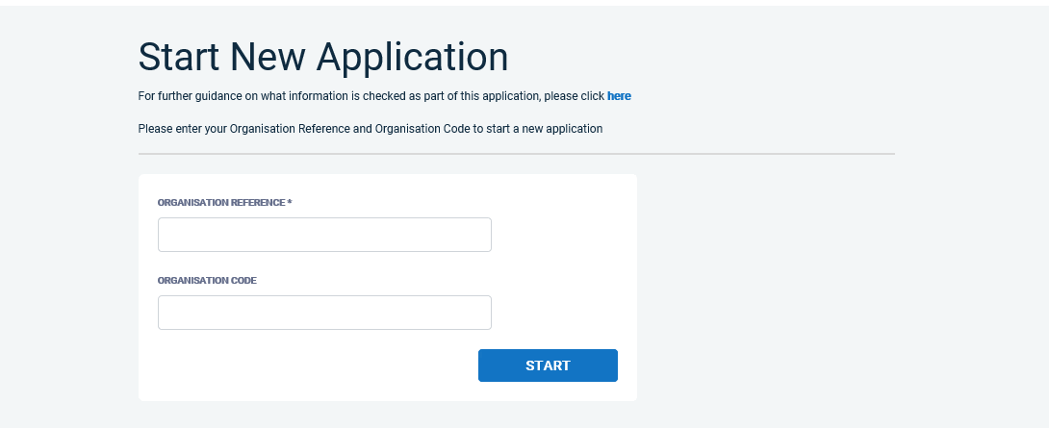

Statement of Fair Processing

You will now be taken to the ‘Statement of Fair Processing’ outlining our terms and conditions. Please read the statement and tick the box to confirm this has been read and agreed to.

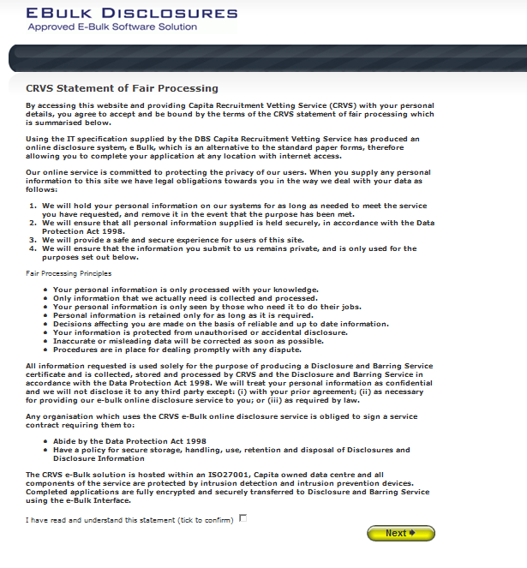

Once you have ticked the consent box please click ‘Next’

Application Pre-Entry Statement

You will now see the application pre-entry statement; this gives concise information in regards to the requirements by the DBS regarding acceptable identification in support of your DBS application.

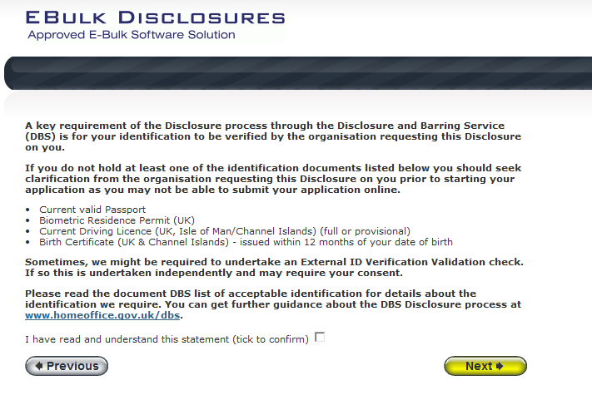

Once you have ticked the consent box please click ‘Next’

- The application form is a simple 5 step process. Please complete all fields.

- Mandatory fields are denoted by (*)

Mistakes on the application form will cause delays in processing.

Section 1 – About You

Please enter your personal details. If you have any middle name(s) ensure that you enter these details, particularly those that appear on your identity documents, e.g. passport, driving licence, birth certificate, etc. Any missing information from this or any other section can severely delay the processing of your criminal record check.

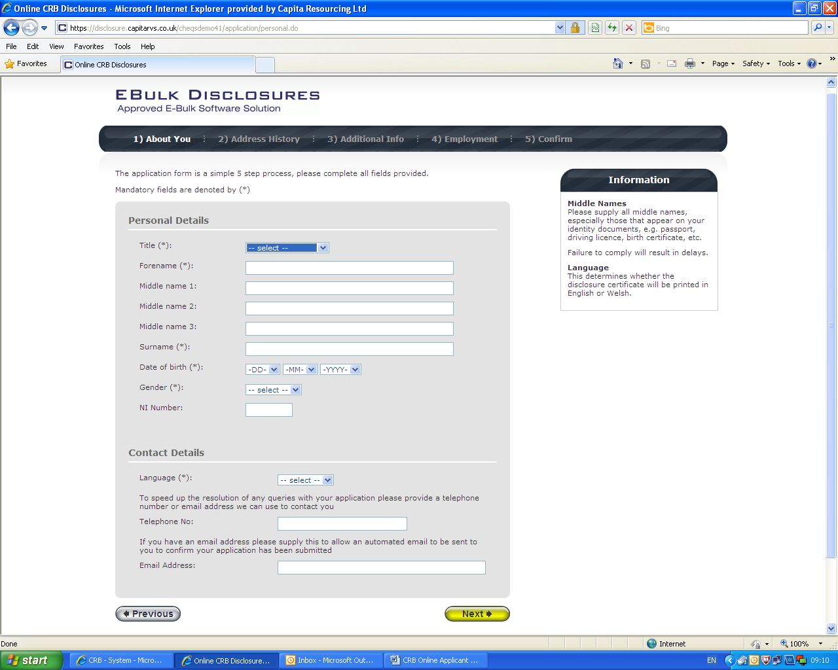

Once you have completed this section click ‘Next’.

Section 2 – Address History

Please enter your current address. If you have not lived at this property for more than five years, you will be taken to another screen. Here you will be required to add any additional addresses to ensure your address history goes back the required five years. Please note if you do not provide a minimum of five years address history, you will not be able to proceed to the next stage of the application process.

Address Dates

There cannot be any gaps/overlaps in your address history. Please ensure that the month and year of each address follows that of the previous address. Students who switch between their permanent residence and education establishments must enter each address with dates consecutively, e.g. parents’ address Dec 2009 – Jan 2010, university address Jan 2010 – March 2010, parents address March 2010 – April 2010 etc. Do not run addresses/dates simultaneously as your application form will be rejected by the DBS. Once an address has been entered, you can edit any information by clicking on the ‘Edit’ button.

Postcode

Please ensure that all UK addresses have a full postcode; if you cannot remember your postcode please use the Royal Mail UK Postcode Finder link provided within the address information box.

No Fixed Abode UK

If you were of no fixed abode within the UK please enter the nearest hostel address to the location you were based.

Foreign Addresses/Travelling Overseas

If you have travelled overseas and cannot supply the address for a foreign country then please enter ‘no fixed abode’ for Address Line 1. Please then enter the Town/City and Country of where you were residing within this period.

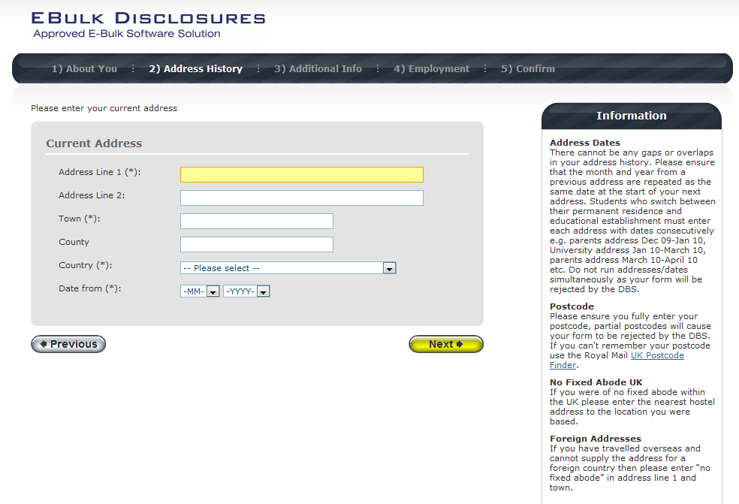
Once you have completed this section click ‘Next’.

Section 3 – Additional Info

Place of Birth

Please enter details of your place of birth.

Nationality at Birth

Please enter your Nationality at birth and state YES or NO as to whether this has changed since you were born. If this has changed, you will be required to enter your current nationality.

Changed Surname

If you have changed your surname please provide your birth surname and the year you changed it. Please ensure that where names change they run in date order and with no gaps.

Other Names

Please provide details of any other names used at any time during your lifetime and the dates during which the names were used. Please enter each forename, middle name(s) and surname separately using the 'Add Name' button below. If you have used any aliases, e.g. William known as Bill, please also supply these details.

Failure to supply any additional information may cause your application to be delayed.

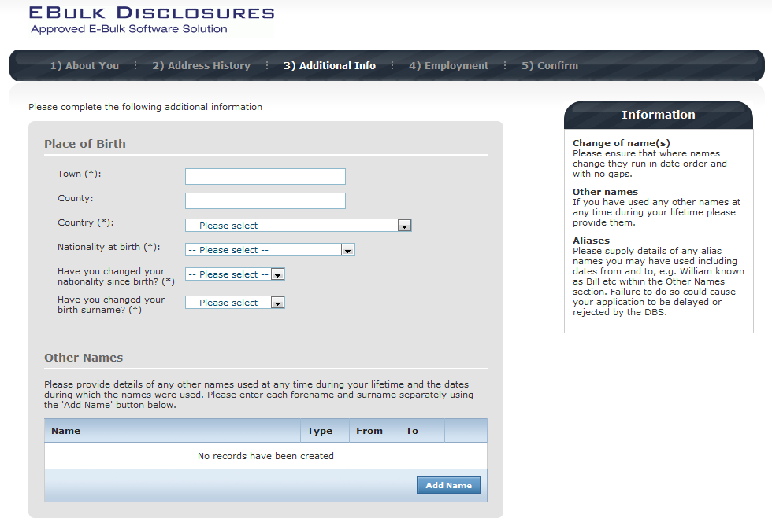

Once you have completed this section click ‘Next’.

Section 4 – Employment Details

Position Applied For

Please insert the job role you have applied for – APPROVED CHAPERONE (VOLUNTEER)

Failure to enter the correct job role may cause your application to be delayed.

Employer Name

This has been defaulted to North Tyneside Council and should not be amended.

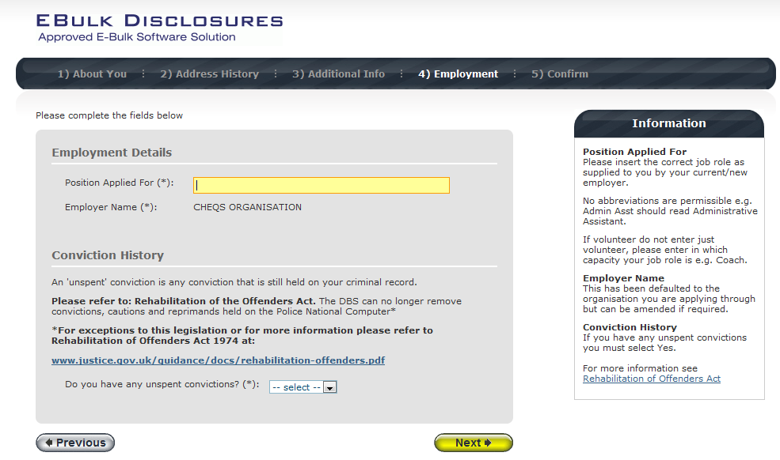

Conviction History

If you have never been convicted of a criminal offence then please select ‘No’.

If you have an ‘unspent’ conviction, then please select ‘Yes’. An 'unspent' conviction is any conviction that is still held on your criminal record.

For exceptions to this legislation or for more information please refer to Rehabilitation of Offenders Act 1974 at:

http://www.justice.gov.uk/guidance/docs/rehabilitation-offenders.pdf

Once you have completed this section click ‘Next’.

Section 5 – Confirmation and Consent

Now please read through your application to ensure that there are no omissions/errors before you submit your application. If you wish to edit a section of your application click on ‘edit’ next to the section of the form that requires changes.

At the end of the application please make sure that you complete the Applicant Consent section.

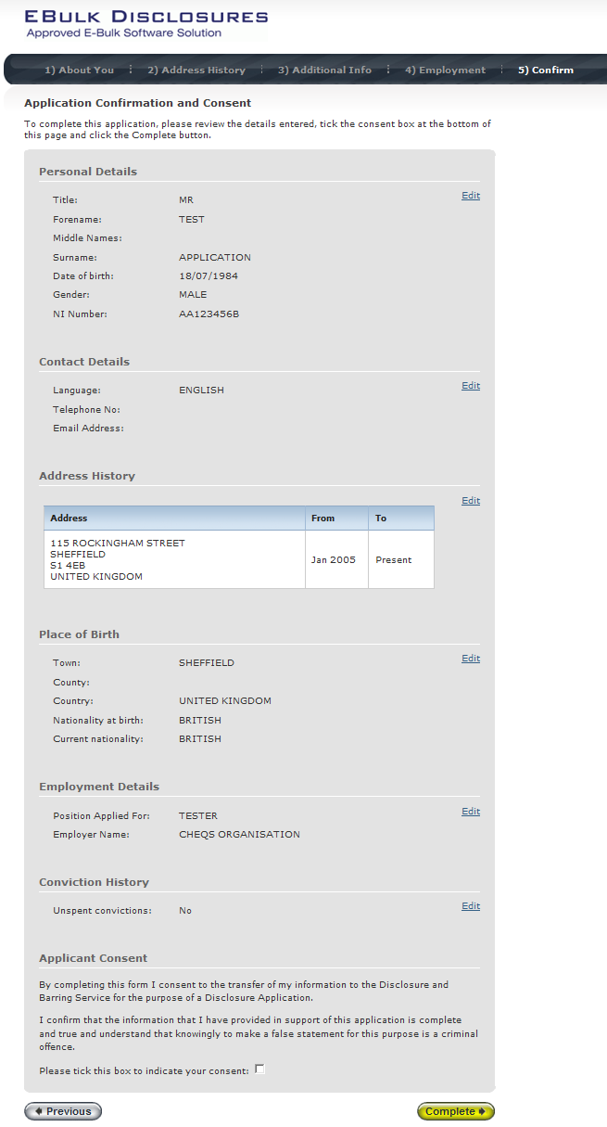

Now click ‘Complete’.

You have now completed your application form and you will be given a submission reference number. Please make a note of this number for reference purposes. If you entered an email address onto your application form you will receive a confirmation email containing these details.

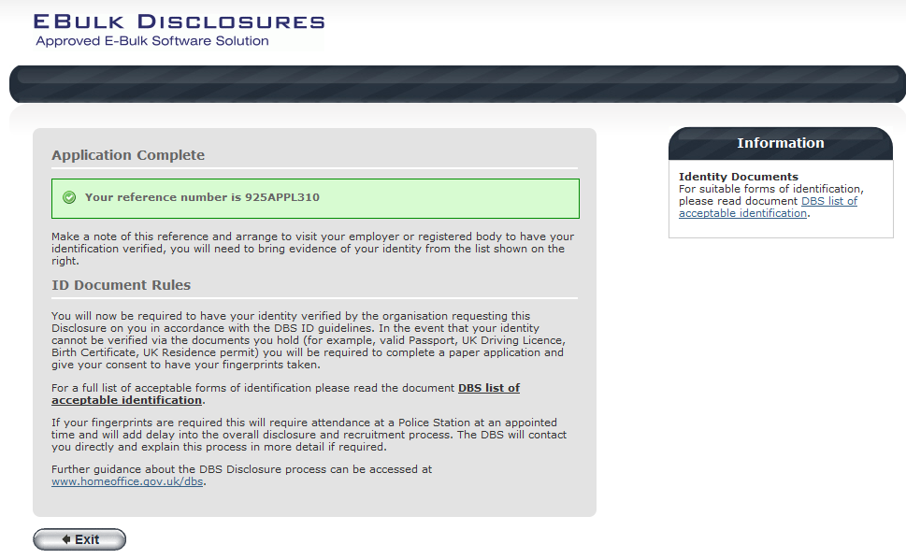

Your application form will be processed by your employer as long as they have verified your identity. Please see below for guidance on identity verification.

Next step - identity verification

In line with the DBS code of practice all applicants requiring a DBS check must have their identity verified.

How do I have my identity verified?

Please provide original identification to your Manager/Identity Checker and provide identification as listed in the acceptable ID table (see table below).

Your application form will be processed by your manager/identity checker once they have verified your identity, and then sent onto the DBS.

Tracking the progress of your application with the DBS

If you supplied an email address whilst entering your application, as soon as your application has been received at the DBS and is assigned a DBS Application Reference number you will receive a second email detailing this information.

This email will also include details and links to the DBS website to enable you to track the progress of your application from the moment the disclosure process commences.

What Documents Do I Need to Produce?

Route 1
Route one must always be attempted to be taken. Three documents in total must be seen; one document must come from Group 1 and a further two documents from Group 1, 2a or 2b. One document must verify your current address.

If you can satisfied this route, then the document you provide will be sufficient. If you cannot produce a Group 1 document then you must go to Route Two.

Route 2
One document must be seen from Group 2a and two further documents from Group 2a or 2b; one of which must verify your current address. You will also be required to undergo an external ID validation service check through Route two, this will be done by your manger/identity checker.

If you have endeavoured to use Route Two, but have been unable to provide the required documents, you must go to Route Three.

Route 3
A Certified copy of a UK Birth Certificate (UK and Channel Islands, issued after the time of birth by the General Register Office/relevant authority) required to be seen and four further documents must be seen from Group 2 comprising of one document from Group 2a and three further documents from Group 2a or 2b; one of which must verify your current address.

If you can not produce the required document set out in Route Three, you will need to contact your manager/identity checker as you will need to complete a paper application.

Group 1 – Primary Trusted Identity Credentials
- Current valid Passport
- Biometric Residence Permit (UK)
- Current Driving Licence (UK, Isle of Man /Channel Islands) (Full or provisional)
  - A photo card is only valid if the individual presents it with the associated counterpart licence (except Jersey)
- Birth Certificate (UK and Channel Islands) - issued at the time of birth;
  - Full or short form acceptable including those issued by UK authorities overseas, such as Embassies, High Commissions and HM Forces. (Photocopies are not acceptable)

Group 2a – Trusted Government/State Issued Documents
- Current UK Driving licence (old style paper version)
- Current Non-UK Photo Driving Licence (valid only for applicants residing outside of the UK at time of application)
- Birth Certificate (UK and Channel Islands) - (issued after the time of birth by the General Register Office/relevant authority i.e. Registrars – Photocopies are not acceptable)
- Marriage/Civil Partnership Certificate (UK and Channel Islands)
- Adoption Certificate (UK and Channel Islands)
- HM Forces ID Card (UK)
- Fire Arms Licence (UK and Channel Islands)

Group 2b – Financial/Social History Documents
- Mortgage Statement (UK or EEA)** (Non-EEA statements must not be accepted)
- Bank/Building Society Statement (UK or EEA)* (Non-EEA statements must not be accepted)
- Bank/Building Society Account Opening Confirmation Letter (UK)
- Credit Card Statement (UK or EEA)* (Non-EEA statements must not be accepted)
- Financial Statement ** - e.g. pension, endowment, ISA (UK)
- P45/P60 Statement **(UK & Channel Islands)
- Council Tax Statement (UK & Channel Islands) **
- Work Permit/Visa (UK) (UK Residence Permit) **
- Utility Bill (UK)* – Not Mobile Telephone
- Benefit Statement* - e.g. Child Allowance, Pension
- A document from Central/ Local Government/ Government Agency/ Local Authority giving entitlement (UK & Channel Islands)*- e.g. from the Department for Work and Pensions, the Employment Service , Customs & Revenue, Job Centre, Job Centre Plus, Social Security
- EU National ID Card
- Cards carrying the PASS accreditation logo (UK and Channel Islands)
- Letter from Head Teacher or College Principal (16/17 year olds in full time education – (only used in exceptional circumstances when all other documents have been exhausted)

Please note:
If a document in the List of Valid Identity Documents is:

- Denoted with * - it should be less than three months old
- Denoted with ** - it should be issued within the past 12 months
- Not denoted – it can be more than 12 months old

Contact Details

Please contact Linda Bollado on 0191 2493847 if you have any queries in regards to the online DBS application process.

