How to Create a Learning Account & Complete the Safeguarding Course

IMPORTANT: If you already have a North Tyneside Learning Pool Account (such as if you are a NT employee or if you have previously completed the course) you already have access; please do not create another user account and proceed straight to Page 4
Follow this link: https://northtyneside.learningpool.com (or type into your browser)
- You will be taken to:
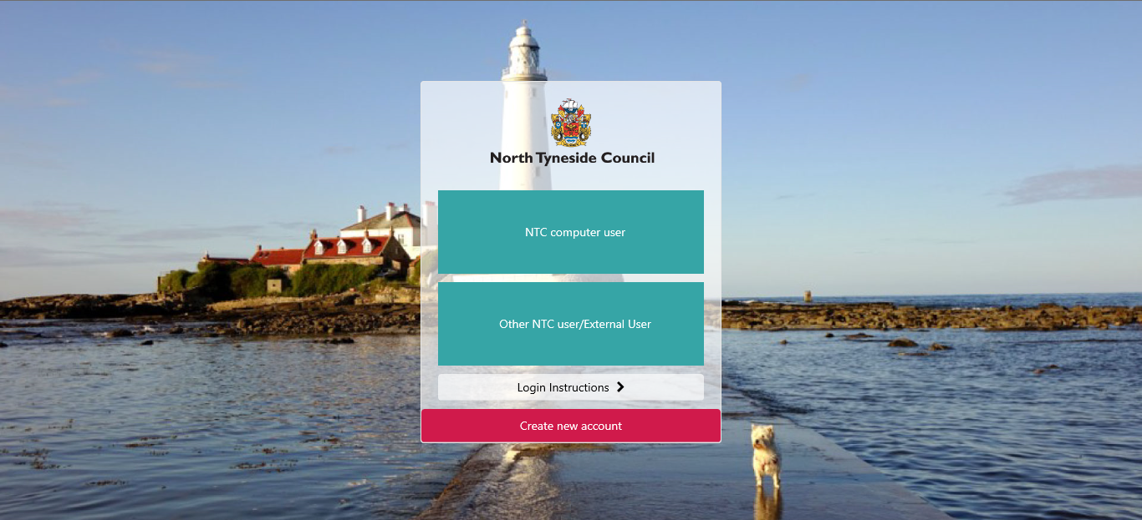

- Select “Create New Account”
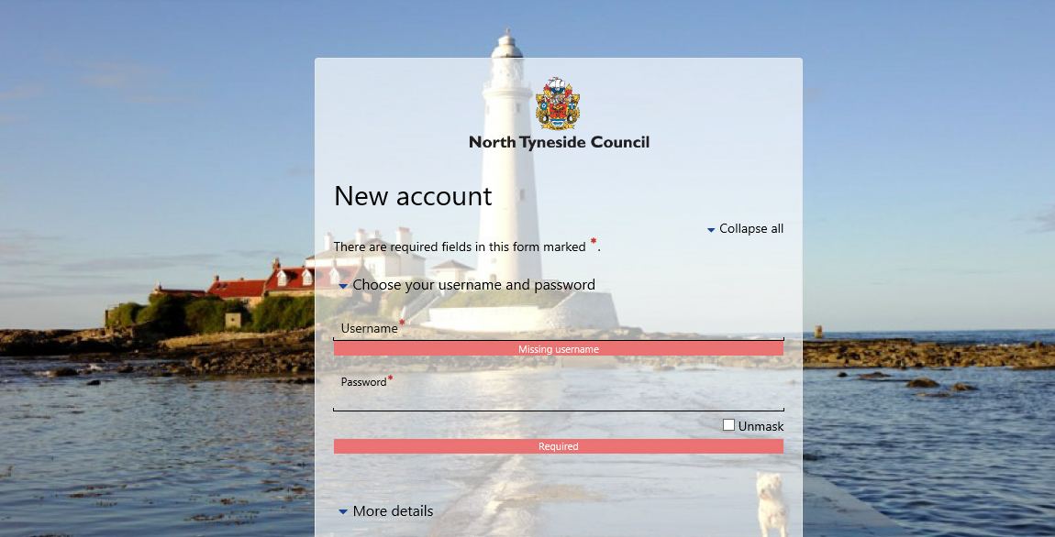

- Create a username and password of your choice

- Complete “More Details”
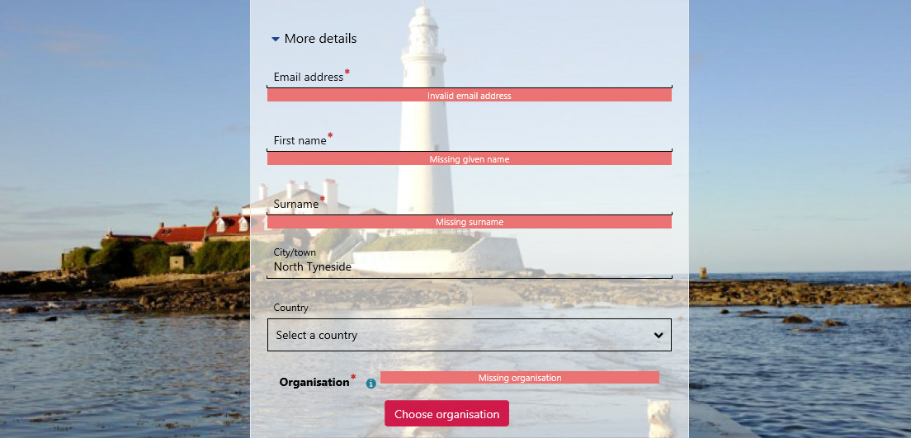

- Then click “choose organisation”
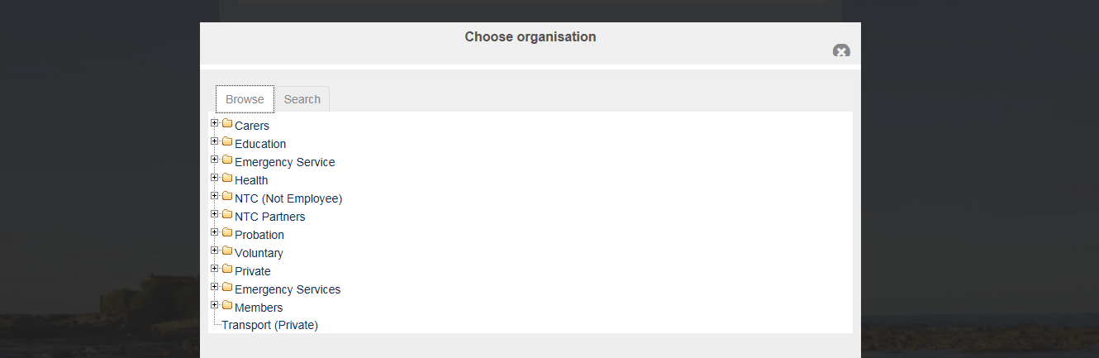

- Click + next to “NTC (Not Employee)
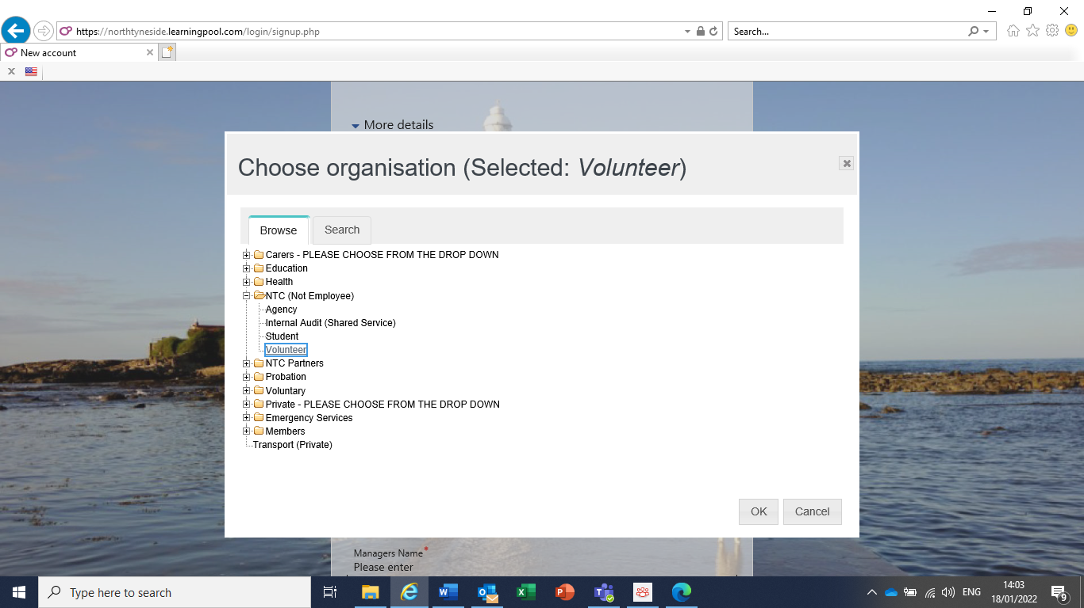

- Select “Volunteer”, then click “OK”
- “Volunteer” will be shown as selected. Now complete “Other fields” (as step 8) below)
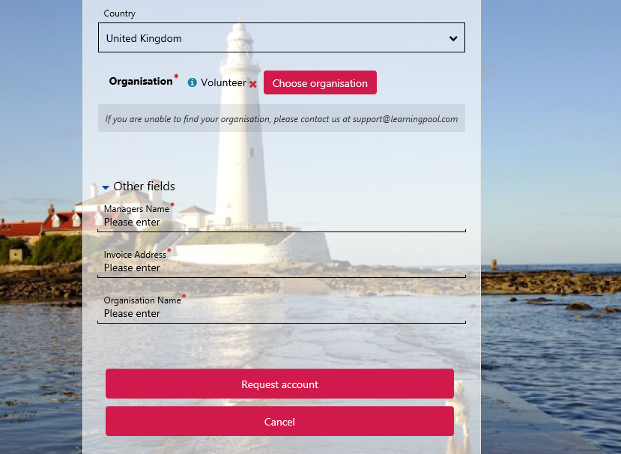

- “Other fields”: Manager’s Name: Helen Jordan
Invoice Address: Attendance & Placement Service Chaperone
Organisation Name: North Tyneside Council

- Click “Request Account”
You will receive an email to confirm your learning account.

You may now log into the Learning Pool and complete the course.

Access the Learning Pool (https://northtyneside.learningpool.com)

If you are an external user and not a North Tyneside Council Employee select:
“Other NTC user”.
If you are a NT Council employee, then select “NTC Computer User”
Then log in using your username and password.

(If you have difficulty logging in or have forgotten your password you should email people.learningandOD@northtyneside.gov.uk)

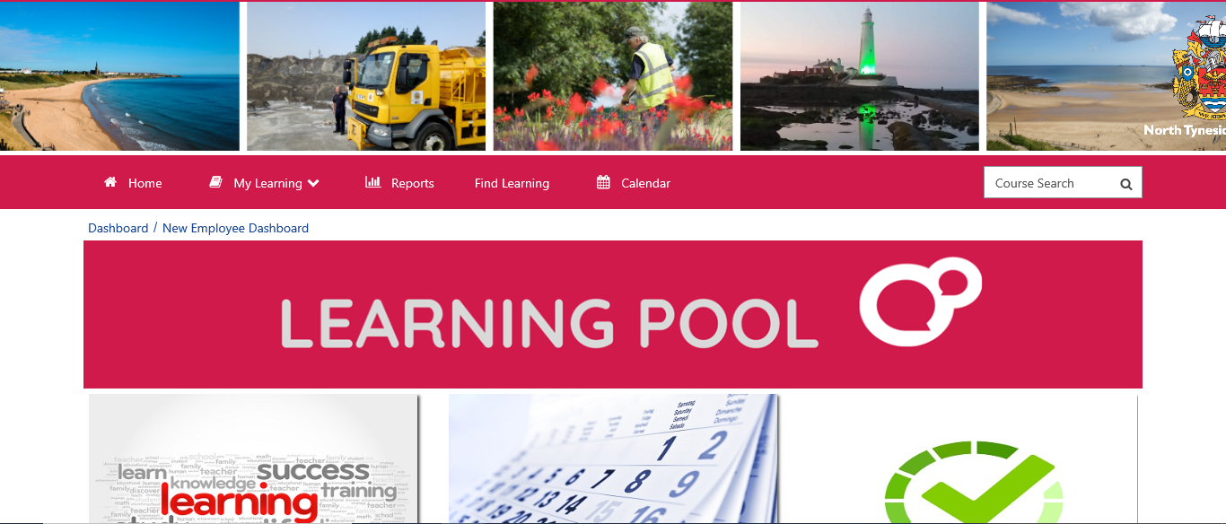

- Locate the course by searching “Risk”

- Select “Safeguarding Children and Adults at Risk in North Tyneside” from the results displayed.

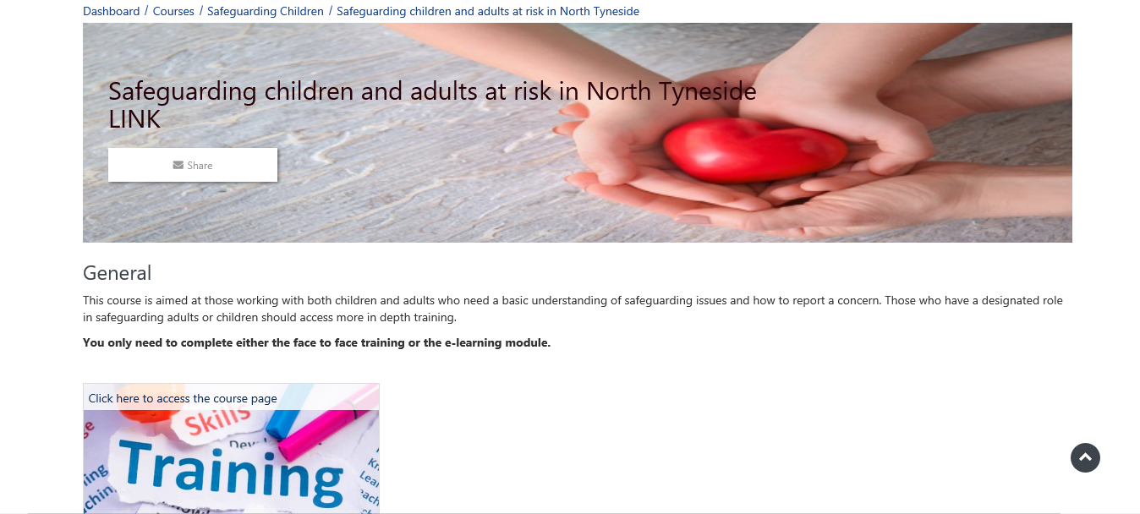

Click here to access the course page
- Click here and complete the course

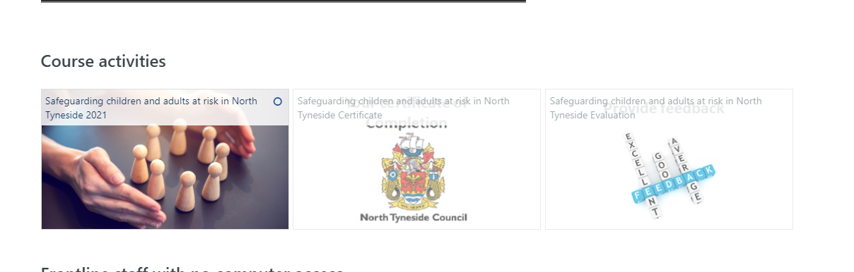

- Obtain your Certificate (you may need to have pop-ups enabled to access this).

If you experience any difficulties creating your learning account or accessing the course please contact the Learning Pool Tel: (0191) 6435063 people.learningandOD@northtyneside.gov.uk

